
CyberNova

Sprint 2 Project Documentation
For
BusNova Bus Management Version 2.0


Submission date: 05 October 2026
For: Mr. D. Boucher
Declaration of Work:
We, CyberNova, declare that:
- The system developed is our original work and has not in part been submitted for the purposes of final assessment for any other 3rd year project module,
- We have the permission to use images shown in our system and have created our own logos that are used in our system,
- Where we have made use of programming assistance, we acknowledge this fact in the acknowledgements section below,
- We did not outsource the building of the entire system to a third party.
Group Members and Roles:
Name and Surname | Student Number | Role(s) | Electronic Signature
Anesipho Kalazana | 202327653 | BA
Elihle Nteyi | 202316017 | BA
Esethu Mtose | 224072208 | BA
Nadia Mpohlekana | 224104608 | PM; DO | 
Olebogeng Gumbu | 224111100 | PR
Simanye Siximba | 224017307 | PR | 
Yonwaba Mgqulwana | 224090097 | BA; DO
Role Key:
PM: Project Manager (only one member can be PM at any given time)
BA: Business Analyst
DO: Documenter
PR: Programmer
A team member can complete multiple roles.

Acknowledgements:
We would like to thank:
1. Lecturers:
- Lecture: Mr D. Boucher | Email: dboucher@ufh.ac.za
- Business Analysis: Assoc. Prof R. Piderit | Email: rpiderit@ufh.ac.za
- Databases: Dr V. Funda | Email: vfunda@ufh.ac.za
- Programming: Mr T. Breetzke | Email: tbreekze@ufh.ac.za

2. Our Mentor: Anelisa Gobingca
Table of Contents
System Matrix 8
System Overview 10
1. Section A: Business Process Description 11
1.1. Use Case Diagram 11
1.2. Use Case Narrative 12
1.2.1. Use Case Narrative: Register 12
1.2.2 Activity Diagram: UC1 Register 14
1.2.3. Use Case Narrative: UC2: Login 15
1.2.4 Activity Diagram: UC2 Login 16
1.2.5. Use Case Narrative: Register Bus 17
1.2.6. Activity Diagram: UC3 Register Bus 18
1.2.7. Use Case Narrative: Create Routes 19
1.2.8. Activity Diagram: UC4 Create Routes 20
1.2.9. Use Case Narrative: Assign Routes 21
1.2.10. Activity Diagram: UC5 Assign Routes 23
1.2.11. Use Case Narrative: View Assigned Routes 24
1.2.12. Activity Diagram: UC6 Assigned Routes 25
1.2.13. Use Case Narrative: View Maintenance Schedule 26
1.2.14. Activity Diagram: UC7 View Maintenance Schedule 27
1.2.15. Use Case Narrative: Review Fuel 28
1.2.16. Activity Diagram: UC8 Review Fuel 29
1.2.19. Use Case Narrative: Monitor Operations 30
1.2.20. Activity Diagram: UC6 Monitor Operations 31
1.2.21. Use Case Narrative: View Routes 32
1.2.22. Activity Diagram: UC13 View Routes 33
1.2.23. Use Case Narrative: Report Fuel 34
1.2.24. Activity Diagram: UC10 Report Fuel 35
1.2.25. Use Case Narrative: Log Servicing Activities 36
1.2.26. Activity Diagram: UC18 Log Servicing Activities 38
1.2.27. Use Case Narrative: Purchase Ticket 39
1.2.28. Activity Diagram: UC15 Purchase Ticket 41
1.2.29. Use Case Narrative: Check availability 42
1.2.30. Activity diagram: UC14 Check availability 43
1.2.31. Use Case Narrative: Report Issues 44
1.2.32. Activity Diagram: UC11 Report Issues 45
2.Section B: Data Modelling Requirements 46
2.1. Entity Relationship Diagram 46
2. 2. Attribute Framing 47
2.2.1. Employees 47
2.2.2. Passengers 48
2.2.3. Bus 49
2.2.4. Bus Schedule 49
2.2.5. Route 50
2.2.6. Route Assignments 51
2.2.7. Maintenance Logs 52
2.2.8. Maintenance Parts 53
2.2.9. Fuel Logs 53
2.2.10. Tickets 54
2.2.11. Tickets Validation 55
2.2.12. Booking 56
2.2.13. Notification 56
2.2.14. Payment Event 57
2.2.15. Payment Refund 57
2.2.16. Payment Transaction 58
2.2.17. Audit Logs 59
2.2.18. Trip Inspection 60
2.2.19. Trip Pin 60
3.Section C: Systems Design Requirements 61
3.1. Windows Navigation Diagram 61
3.2. Screen Design Specification 62
3.2.1. Screen 01: Home Page 62
3.2.2. Screen 02: Register 63
3.2.3. Screen 03: Login 65
3.2.4. Screen 04: Manager Dashboard 66
3.2.5. Screen 05: Bus Driver Dashboard 68
3.2.6. Screen 06: Passenger Dashboard 69
3.2.7. Screen 07: Maintenance Staff Dashboard 70
3.2.8. Screen 08: Manage Users 71
3.2.9. Screen 09: Log Fuel 72
3.2.10. Screen 10: Report Issue 73
3.2.11. Screen 11: Register Bus 74
3.2.12. Screen 12: Create Routes 75
3.2.13. Screen 13: Assign Routes 76
3.2.14. Screen 14: View Assigned Routes 77
3.2.15. Screen 15: Issue Ticket 78
3.2.16. Screen 16: Ticket 79
3.2.17. Screen 17: Route Completion 80
3.2.18. Screen 18: Fuel Efficiency 81
3.2.19. Screen 19: Driver Performance 82
3.2.20. Screen 20: Maintenance Due 83
Sprint Backlog - Sprint 1 86
Risk Log 88
Sprint Progress Report 89

List of Figures
Figure 1 Use Case Diagram 10
Figure 2 Activity Diagram: UC1 Register 13
Figure 3 Activity Diagram: UC2 Login 15
Figure 4 Activity Diagram: UC3 Register Bus 17
Figure 5 Activity Diagram: UC4 Create Routes 19
Figure 6 Activity Diagram: UC5 Assign Routes 22
Figure 7 Assigned Routes Activity Diagram 24
Figure 8 Activity Diagram: UC7 View Maintenance Schedule 26
Figure 9 Activity Diagram: UC8 Review Fuel 28
Figure 10 Activity Diagram: UC6 Monitor Operations 30
Figure 11 Activity Diagram: UC13 View Routes 32
Figure 12 Activity Diagram: UC10 Report Fuel 34
Figure 13 Activity Diagram: UC18 Log Servicing Activities 37
Figure 14 Activity Diagram: UC15 Purchase Ticket 40
Figure 15 Activity diagram: UC14 Check availability 42
Figure 16 Activity Diagram: UC11 Report Issues 44
Figure 17 Entity Relationship Diagram 45
Figure 18 Windows Navigation Diagram 60
Figure 19 Screen 01: Home Page 61
Figure 20 Screen 02: Register 62
Figure 21 Screen 03: Login 64
Figure 22 Screen 04: Manager Dashboard 65
Figure 23 Screen 05: Bus Driver Dashboard 67
Figure 24 Screen 06: Passenger Dashboard 68
Figure 25 Screen 07: Maintenance Staff Dashboard 69
Figure 26 Screen 08: Manage Users 70
Figure 27 Screen 09: Log Fuel 71
Figure 28 Screen 10: Report Issue 72
Figure 29 Screen 11: Register Bus 73
Figure 30 Screen 12: Create Routes 74
Figure 31 Screen 13: Assign Routes 75
Figure 32 Screen 14: View Assigned Routes 76
Figure 33 Screen 15: Issue Ticket 77
Figure 34 Screen 16: Ticket 78
Figure 35 Screen 17: Route Completion 79
Figure 36 Screen 18: Fuel Efficiency 80
Figure 37 Screen 19: Driver Performance 81
Figure 38 3.2.20. Screen 20: Maintenance Due 82

List of Tables
Table 1 System Matrix 10
Table 2 Use Case Narrative: Register 14
Table 3 Use Case Narrative: UC2: Login 16
Table 4 Use Case Narrative: Register Bus 18
Table 5 Use Case Narrative: Create Routes 20
Table 6 Use Case Narrative: Assign Routes 23
Table 7 Use Case Narrative: View Assigned Routes 25
Table 8 Use Case Narrative: View Maintenance Schedule 27
Table 9 Use Case Narrative: Review Fuel 29
Table 10 Use Case Narrative: Monitor Operations 31
Table 11 Use Case Narrative: View Routes 33
Table 12 Use Case Narrative: Report Fuel 35
Table 13 Use Case Narrative: Log Servicing Activities 38
Table 14 Use Case Narrative: Purchase Ticket 41
Table 15 Use Case Narrative: Check availability 43
Table 16 Use Case Narrative: Report Issues 45
Table 17 Employees 48
Table 18 Passengers 49
Table 19 Bus 50
Table 20 Bus Schedule 50
Table 21 Route 51
Table 22 Route Assignments 52
Table 23 Maintenance Logs 53
Table 24 Maintenance Parts 54
Table 25 Fuel Logs 54
Table 26 Tickets 55
Table 27 Tickets Validation 56
Table 28 Booking 57
Table 29 Notification 57
Table 30 Payment Event 58
Table 31 Payment Refund 58
Table 32 Payment Transaction 59
Table 33 Audit Logs 60
Table 34 Trip Inspection 61
Table 35 Trip Pin 61
Table 36 Screen Narrative and Controls: SC1 63
Table 37 Screen Narrative and Controls: SC2 65
Table 38 Screen Narrative and Controls: SC3 66
Table 39 Screen Narrative and Controls: SC04 68
Table 40 Screen Narrative and Controls: SC05 69
Table 41 Screen Narrative and Controls: SC06 70
Table 42 Screen Narrative and Controls: SC07 71
Table 43 Screen Narrative and Controls: SC08 72
Table 44 Screen Narrative and Controls: SC09 73
Table 45 Screen Narrative and Controls: SC10 74
Table 46 Screen Narrative and Controls: SC11 75
Table 47 Screen Narrative and Controls: SC12 76
Table 48 Screen Narrative and Controls: SC13 77
Table 49 Screen Narrative and Controls: SC14 78
Table 50 Screen Narrative and Controls: SC15 79
Table 51 Screen Narrative and Controls: SC16 80
Table 52 Screen Narrative and Controls: SC17 81
Table 53 Screen Narrative and Controls: SC18 82
Table 54 Screen Narrative and Controls: SC19 83
Table 55 Screen Narrative and Controls: SC20 84

System Matrix
Business Process | Reference | Use Case | Table | Screen | Report
Register an account | UC1 | Register | User | SC2 | List of Registered Users
Login to the system | UC2 | Login | User | SC3 | Login Activity Report
Register buses | UC3 | Register bus | Bus | SC4 | Registered Buses Report
Create routes | UC4 | Create route | Route | SC5 | Route List Report
Assign routes | UC5 | Assign route | Route Assignment | SC6 | Route Assignment Report
Monitor bus operations | UC6 | Monitor operations |  | SC8 | Bus Operations Report
Review reports on route completion | UC7 | View reports | Route | SC9 | Route Completion Report
Review fuel efficiency | UC8 | Review fuel | FuelLog | SC10 | Fuel Efficiency Report
View assigned routes & schedule | UC9 | View assigned routes | RouteAssignment | SC7 | Driver Schedule Report
Report fuel usage | UC10 | Report Fuel | FuelLog | SC11 | Fuel Usage Report
Report maintenance issues | UC11 | Report Issue | MaintenanceLog | SC12 | Maintenance Issues Report
Update trip status | UC12 | Update Status |  | SC13 | Trip Status Report
View bus routes | UC13 | View Routes | Route | SC14 | Route Report
Check availability | UC14 | Check Availability | Bus | SC15 | Bus Availability Report
Purchase ticket | UC15 | Purchase Ticket | Ticket | SC16 | Ticket Sales Report
Receive confirmation email | UC16 | Receive Confirmation | Ticket | SC17 | Booking Confirmation Report
View maintenance schedule | UC17 | View Maintenance Schedule | MaintenanceLog | SC18 | Maintenance Schedule Report
Log reports and servicing activities | UC18 | Log Service Activities | MaintenanceLog | SC19 | Service History
Update vehicle condition | UC19 | Update Vehicle Status | MaintenanceLog, Bus | SC20 | Vehicle Condition Report
Receive alerts for upcoming and overdue services | UC20 | Receive Maintenance Alerts | MaintenanceLog | SC21 | Maintenance Alert Report
Adding employees to the system | UC21 | Register employees |  | SC22 | N/A
Table 1 System Matrix

System Overview
BusNova is an integrated Bus Management System designed to centralise and streamline the management of bus fleet operations, transportation services and vehicle maintenance. The system provides role-based functionality for Fleet Managers, Bus Drivers, Passengers and Maintenance Staff, enabling users to perform activities according to their responsibilities. These include user registration and authentication, bus registration, route creation and assignment, trip-status updates, passenger ticket purchasing, fuel monitoring, maintenance management and operational reporting.
The system connects these processes through a centralised database containing information relating to users, buses, routes, route assignments, tickets, fuel logs and maintenance records. Fleet Managers can allocate available buses and drivers to routes while the system validates availability to prevent scheduling conflicts. Drivers can access assigned routes and schedules, while Maintenance Staff can monitor servicing schedules, record maintenance activities and receive alerts for overdue services. Passengers can view routes, check availability, purchase tickets and receive booking confirmations.
BusNova supports Sustainable Development Goal 9 (Industry, Innovation and Infrastructure) by digitally integrating and improving transportation infrastructure management. It supports SDG 11 (Sustainable Cities and Communities) by facilitating organised and accessible public transportation services. The system also contributes to SDG 12 (Responsible Consumption and Production) through fuel-usage and fuel-efficiency monitoring, as well as preventative vehicle maintenance. These functions collectively promote more efficient resource utilisation and sustainable transport operations.
Overall, BusNova provides a unified platform that improves operational coordination, information accuracy, fleet visibility and decision-making across the bus management environment.

1. Section A: Business Process Description

1.1. Use Case Diagram
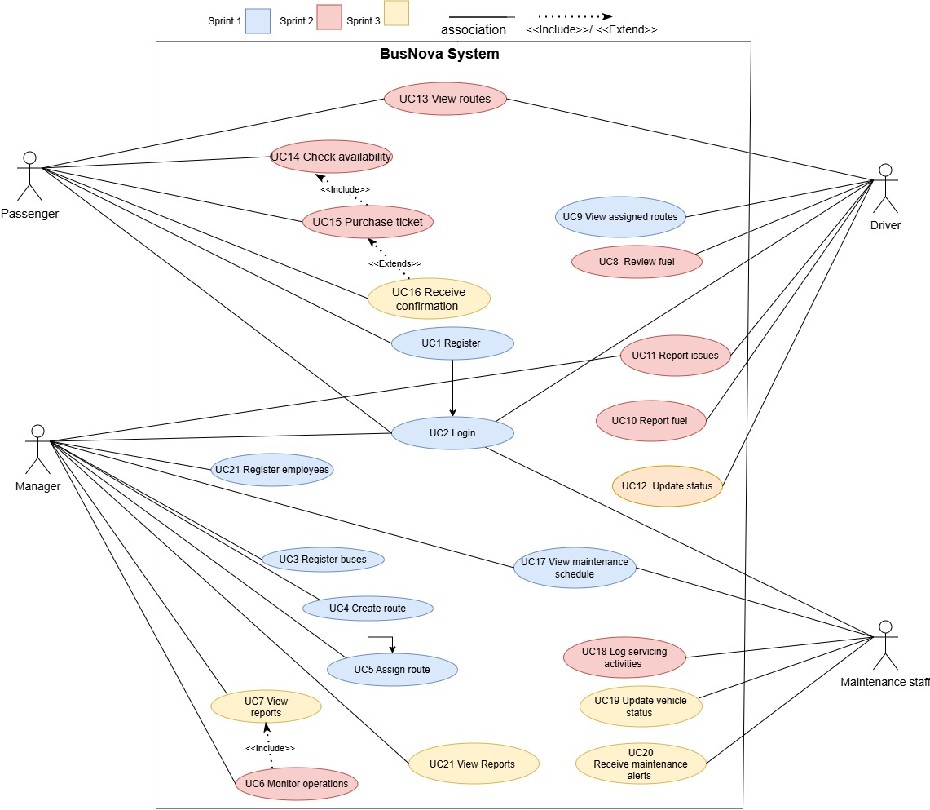
Figure 1 Use Case Diagram

1.2. Use Case Narrative

1.2.1. Use Case Narrative: Register
BusNova
Use Case Specification
Use Case Id | UC1
User Case Name | Register
Actor(s) | Passenger
Brief Description | A new passenger registers an account by entering their details. The system validates the information, checks whether the email address already exists, encrypts the password, stores the user's information in the database, creates the account, and redirects the user to the login page upon successful registration.
Frequency of use | Once per passenger.
Preconditions | 1. The passenger has access to the BusNova registration page.  2. The passenger does not already have a registered account.
Main Flow of Events | Actor |  | System
Main Flow of Events | 1. Opens the Registration page.  2. Enters details in the registration form.  3. Clicks Register button.  3.4. If YES, the email exists, user re-enters details with a new email. |  | 1.2. Displays the registration form.  3.1. Validates the entered information.  3.2. Checks whether the email address exist in the database.  3.3. If NO the email address does not exist, the system encrypts the password and proceeds to create the account.  4. Displays a registration success message.  5. Redirects the passenger to the Login page upon successful registration.
Alternative Flows of Events | If required fields are missing, invalid, or the email address already exists, the system displays a validation error message and returns the passenger to the Registration form to correct the information.
Postconditions | A new Passenger account is created and stored in the User table. The passenger can subsequently log in to access ticket purchasing and route information.
Special Requirements | 1. Password must be encrypted before storage.  2. Email address must be unique across all roles.  3. Role must be correctly recorded as "Passenger" for this account.
Created by | Elihle Nteyi | Last Modified by |  | Yonwaba Mqulwana
Date | 01 August 2026 | Date |  | 02 September 2026
Table 2 Use Case Narrative: Register

1.2.2 Activity Diagram: UC1 Register
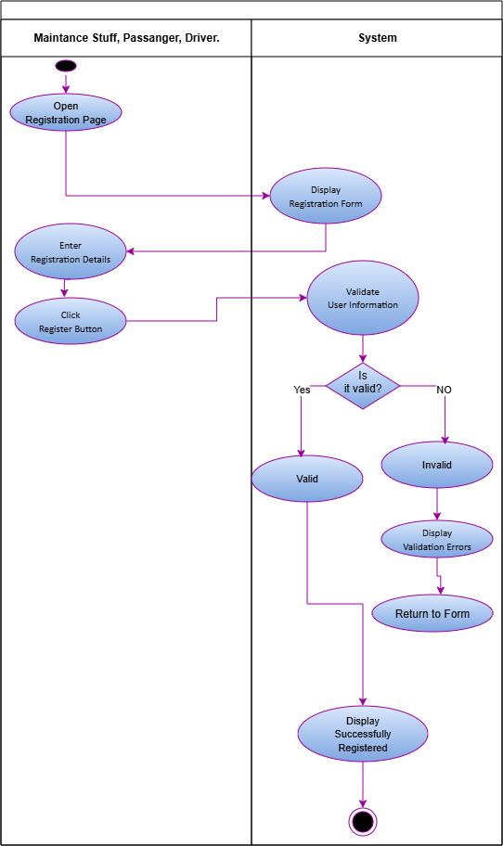
Figure 2 Activity Diagram: UC1 Register

1.2.3. Use Case Narrative: UC2: Login
BusNova
Use Case Specification
Use Case Id | UC2
User Case Name | Login
Actor(s) | Manager, Bus Driver, Passenger, Maintenance Staff
Brief Description | The user enters their login details to access the system.
Frequency of use | Daily, whenever a user wants to access the system.
Preconditions | 1. The user must have a registered account.  2. The user logs into the system using their email and password.
Main Flow of Events | Actor |  | System
Main Flow of Events | 1. Clicks Login.  2. Enters email and password.  3. Click “Login” |  | 1.1 Display login page.  3.1 Verify credentials  3.2 Grant access/Display error message and redirects back to input.  3.3 Displays user dashboard.
Alternative Flows of Events | 1. Account does not exist  2. The entered password or email does not match, the system displays the error message "Invalid login details."
Postconditions | The user has successfully logged into the system using their email and password and is taken to their role-specific dashboard.
Special Requirements | Passwords must be encrypted. Login credentials must be validated against the database. Access and dashboard content must be based on the user's role.
Created by | Yonwaba Mgqulwana | Last Modified by |  | Simanye Siximba
Date | 30 July 2026 | Date |  | 02 September 2026
Table 3 Use Case Narrative: UC2: Login

1.2.4 Activity Diagram: UC2 Login
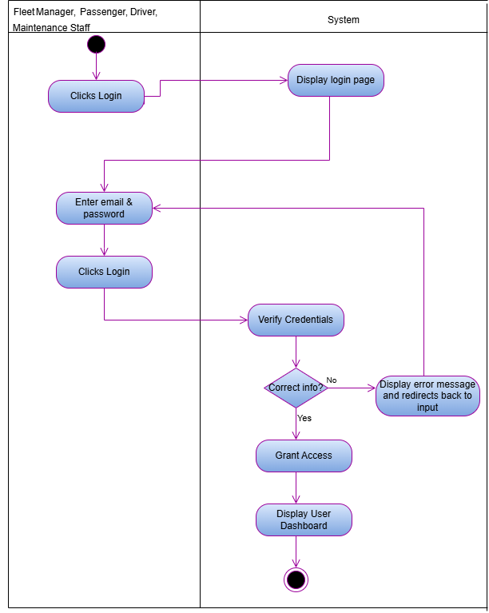
Figure 3 Activity Diagram: UC2 Login

1.2.5. Use Case Narrative: Register Bus
BusNova
Use Case Specification
Use Case Id | UC3
User Case Name | Register Buses
Actor(s) | Manger
Brief Description | A fleet manager registers a new bus into the system by providing bus details such as registration number, model, manufacturer, seating capacity and fuel type. After successful registration, the bus becomes available for route assignment and scheduling.
Frequency of use | Low
Preconditions | Fleet Manager is logged in with an active session (role-based access, no separate permission check).
Main Flow of Events | Actor |  | System
Main Flow of Events | 1. Selects “Register Buses”.  2. Enters the bus details.  3. Clicks “Save/Register”. |  | 1.1 Displays an empty bus registration form.  3.1 Validates required fields and checks registration number uniqueness.  3.2 Saves the bus record and displays a confirmation message. “Bus registered successfully”.
Alternative Flows of Events | 1. If required fields are missing or invalid, the system highlights the errors and remains on the form.  2. If the registration number already exists, the system reminds the fleet manager to enter a different registration number.
Postconditions | New bus record is stored in the database, bus becomes available for route assignment, driver scheduling and maintenance scheduling.
Special Requirements | Registration number must be unique; seating capacity must be a positive number.
Created by | Anesipho Kalazana | Last Modified by |  | Elihle Nteyi
Date | 03 August 2026 | Date |  | 07 August 2026
Table 4 Use Case Narrative: Register Bus

1.2.6. Activity Diagram: UC3 Register Bus
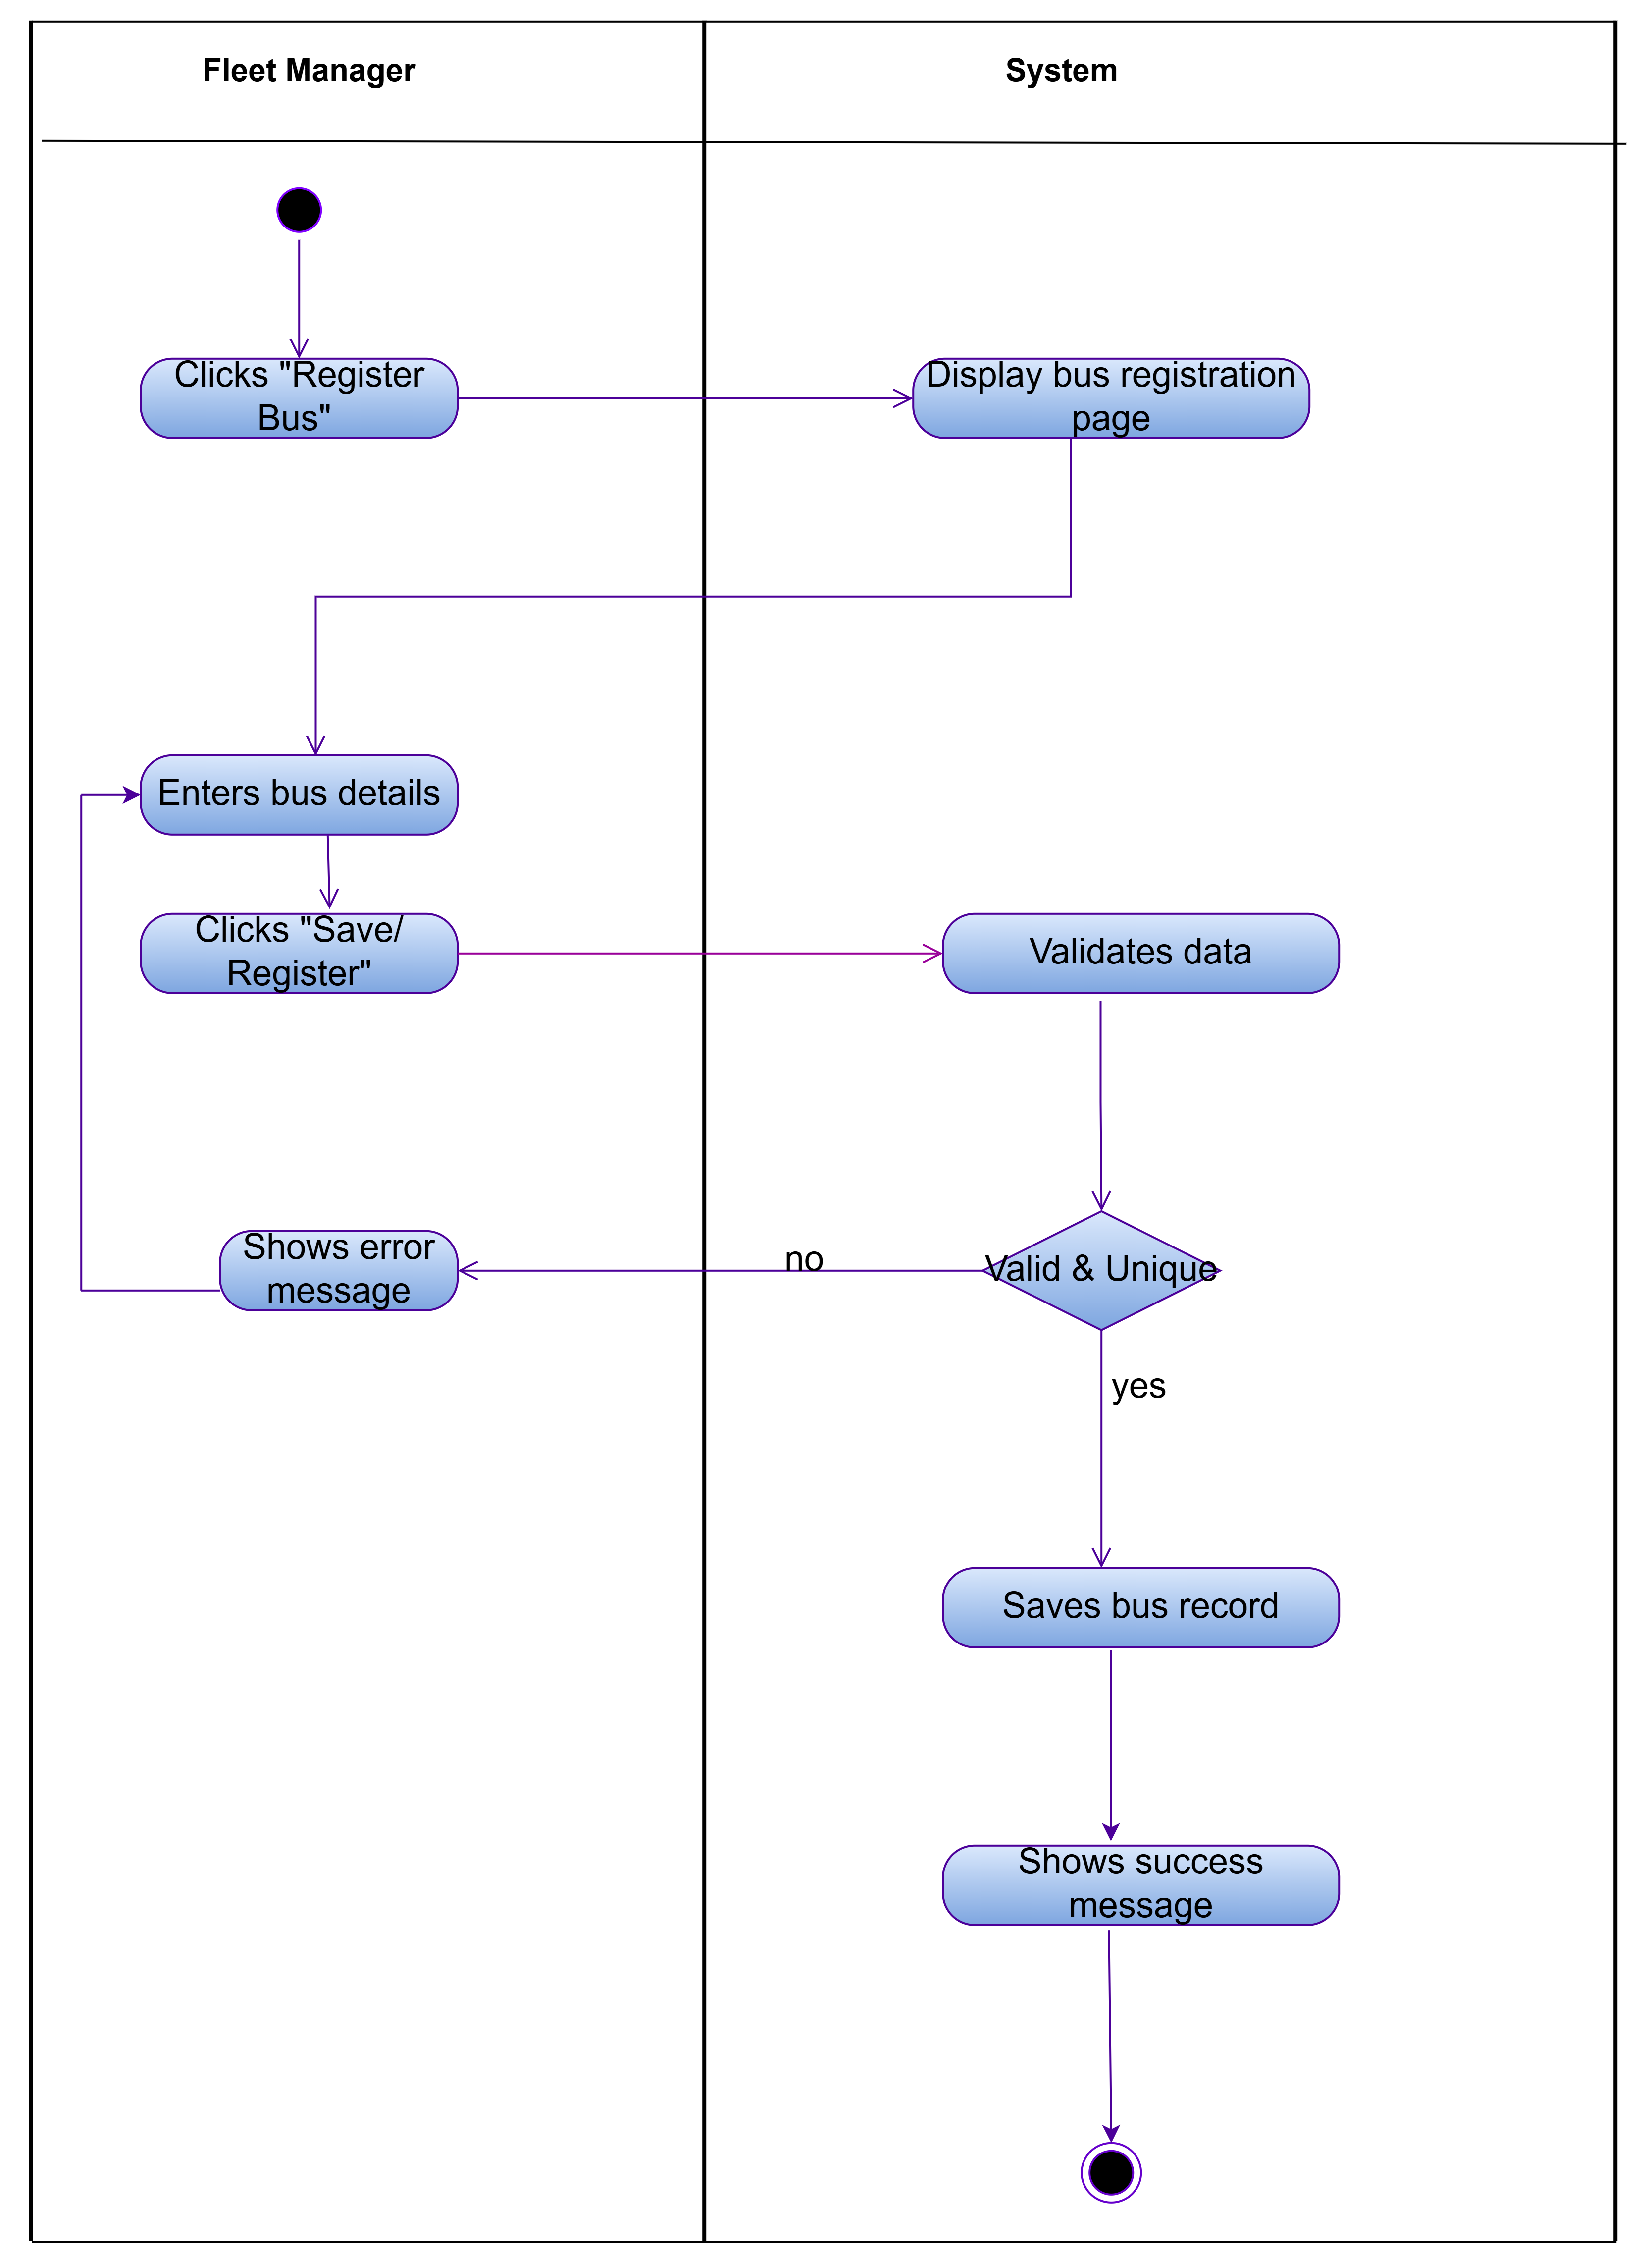
Figure 4 Activity Diagram: UC3 Register Bus

1.2.7. Use Case Narrative: Create Routes
BusNova
Use Case Specification
Use Case Id | UC4
User Case Name | Create Routes
Actor(s) | Manager
Brief Description | Describes how the Fleet Manager defines a new bus route in the system.
Frequency of use | As needed, whenever new routes must be added or existing service areas expanded.
Preconditions | The Fleet Manager is logged into the system with valid credentials.
Main Flow of Events | Actor |  | System
Main Flow of Events | 1. Select the "Create Routes".  2. Enters the route details and adds intermediate stops.  3. Submits the route for saving |  | 1.1. Displays the route creation form.  3.1. Validates the entered data.  3.2. Checks that the route ID/name is unique.  3.3. Saves the new route to the database.  3.4. Displays a confirmation message.
Alternative Flows of Events | If required fields are missing or incorrectly formatted, the system displays an error message and returns the Fleet Manager to step 3.
Postconditions | Success: A new route record is created and saved in the system database.
Special Requirements | The system must validate all route details before saving and ensure that the information complies with the database constraints.
Created by | Nadia Mpohlekana | Last Modified by |  | Anesipho Kalazana
Date | 28 July 2026 | Date |  | 07 August 2026
Table 5 Use Case Narrative: Create Routes

1.2.8. Activity Diagram: UC4 Create Routes
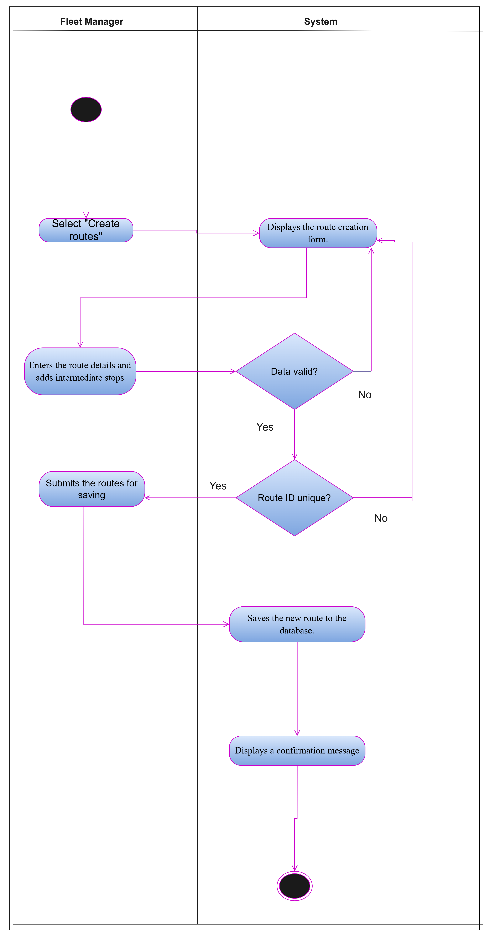
Figure 5 Activity Diagram: UC4 Create Routes

1.2.9. Use Case Narrative: Assign Routes
BusNova
Use Case Specification
Use Case Id | UC5
User Case Name | Assign routes
Actor(s) | Fleet manager
Brief Description | The Fleet Manager assigns an available bus and driver to a specific route and schedule. The system validates the availability of the selected bus and driver before saving the assignment and updating the schedule
Frequency of use | Whenever a new route needs to be assigned or an existing assignment needs to be updated
Preconditions | The Fleet Manager is logged into the system; driver must be valid before a route assignment can be performed
Main Flow of Events | Actor |  | System
Main Flow of Events | 1. Selects Assign Routes  2. Selects the route  3. Selects bus  4. Selects driver  5. Click “Assign Route” |  | 1.1 Displays routes, buses, and drivers  2.1 Displays route details  5.1 Validates bus availability  5.2 Display “Bus unavailable” and return to Select bus  5.3 Validates driver availability  5.4 Display “Driver unavailable” and return to Select driver  5.5 Save route assignment  5.6 Updates driver’s schedule  5.7 Updates bus allocation  5.8 Display confirmation message
Alternative Flows of Events | 1. If the selected bus unavailable the system shows an error message  2. If the selected driver is already assigned to another route, the system displays an error message
Postconditions | Upon completion of the route assignment process, the system saves the assignment.
Special Requirements | The system must allow only Fleet Managers to assign routes and must validate the availability of the selected bus and driver before saving the assignment.
Created by | Olebogeng Gumbu | Last Modified by |  | Yonwaba Mqulwana
Date | 29 July 2026 | Date |  | 29 August 2026
Table 6 Use Case Narrative: Assign Routes

1.2.10. Activity Diagram: UC5 Assign Routes
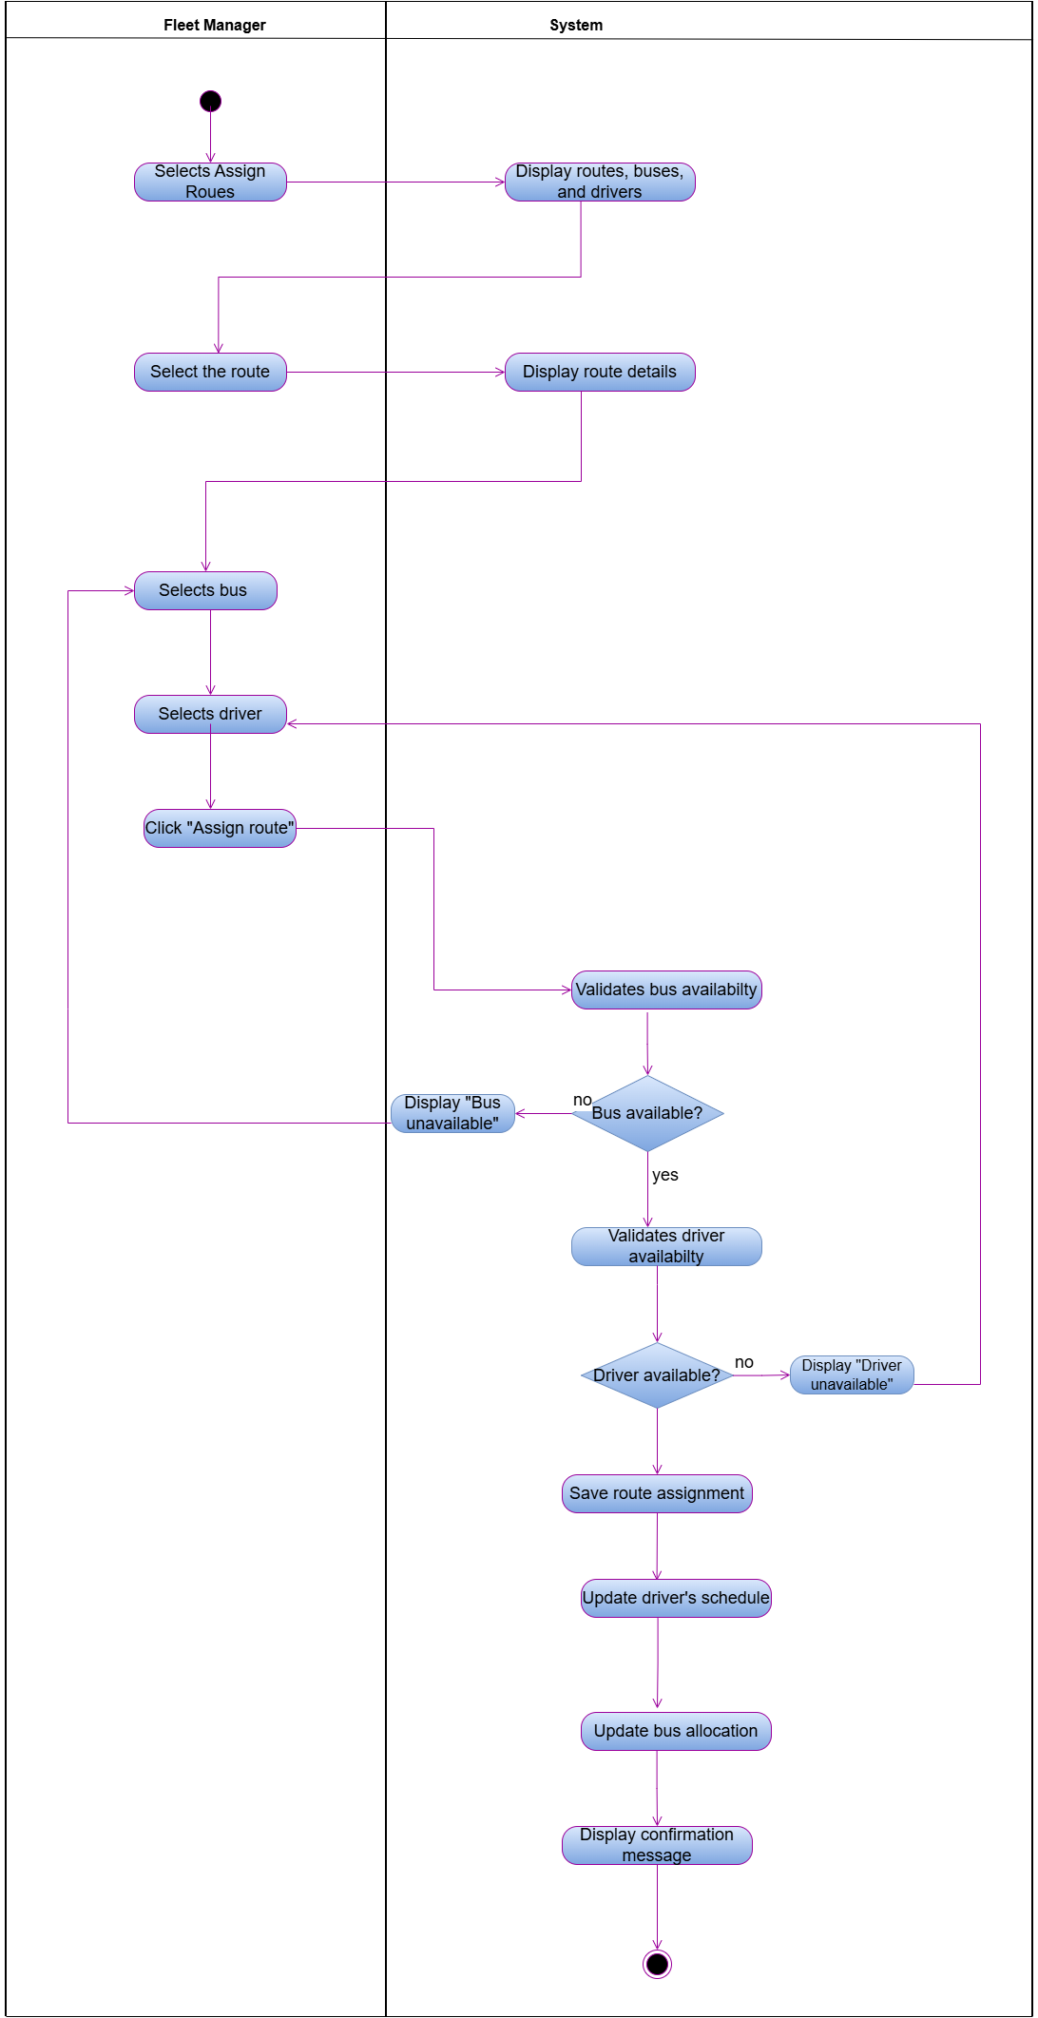
Figure 6 Activity Diagram: UC5 Assign Routes

1.2.11. Use Case Narrative: View Assigned Routes
Fleet Management System
Use Case Specification
Use Case Id | UC9
User Case Name | View Assigned Routes
Actor(s) | Driver
Brief Description | The Driver views the routes and trip schedule assigned to them, including trip details such as route path, stops, and pickup/drop-off times.
Frequency of use | Daily
Preconditions | 1. The Driver has a registered account and is logged into the system.  2. Routes/trips have been assigned to the driver.
Main Flow of Events | Actor |  | System
Main Flow of Events | 1. Driver logs in.  2. Driver navigates to "My Schedule" or "Assigned Routes".  3. Driver selects a route/trip to view further details. |  | 1.1 Authenticate the user.  2.1 Retrieve and display the routes and trip schedule assigned to the driver.  3.1 Display detailed trip information (route path, stops, pickup/drop-off times, assigned bus).
Alternative Flows of Events | No routes/trips have been assigned to the driver, System displays "No routes assigned".
Postconditions | The Driver has viewed their assigned routes and trip schedule. No data is modified by this use case.
Special Requirements | Schedule information must reflect real-time updates; driver view must be usable on mobile devices.
Created by | Siximba Simanye | Last Modified by |  | Yonwaba Mqulwana
Date | 03 August 2026 | Date |  | 07 August 2026
Table 7 Use Case Narrative: View Assigned Routes

1.2.12. Activity Diagram: UC6 Assigned Routes
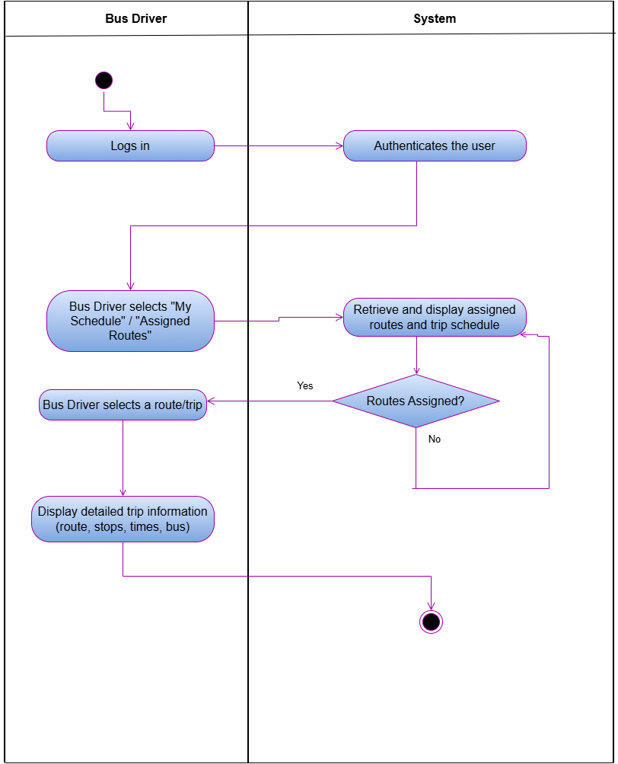
Figure 7 Assigned Routes Activity Diagram

1.2.13. Use Case Narrative: View Maintenance Schedule
Fleet Management System
Use Case Specification
Use Case Id | UC17
User Case Name | View Maintenance Schedule
Actor(s) | Maintenance Staff
Brief Description | Maintenance Staff view the maintenance and servicing schedule for buses in the fleet.
Frequency of use | Medium
Preconditions | 1. Maintenance Staff has a registered account and is logged into the system.
Main Flow of Events | Actor |  | System
Main Flow of Events | 1. Maintenance Staff logs in.  2. Maintenance Staff navigates to "Maintenance Schedule".  3. Maintenance Staff filters or searches records by bus, date, or status.  4. Maintenance Staff selects a service record to view further details. |  | 1.1 Authenticate the user.  2.1 Display the Maintenance Schedule screen.  3.1 Retrieve and display the matching maintenance or service records.  4.1 Display detailed service information: last service date, next due date, service type, status.  4.2 If overdue, highlight the record and trigger an alert.
Alternative Flows of Events | No maintenance records match the filter criteria, System displays "No maintenance records found".
Postconditions | Maintenance Staff has reviewed the maintenance schedule, with overdue services flagged. No data is modified by this use case.
Special Requirements | Schedule information must reflect real-time updates.
Created by | Siximba Simanye | Last Modified by |  | Nadia Mpohlekana
Date | 03 August 2026 | Date |  | 06 August 2026
Table 8 Use Case Narrative: View Maintenance Schedule

1.2.14. Activity Diagram: UC7 View Maintenance Schedule
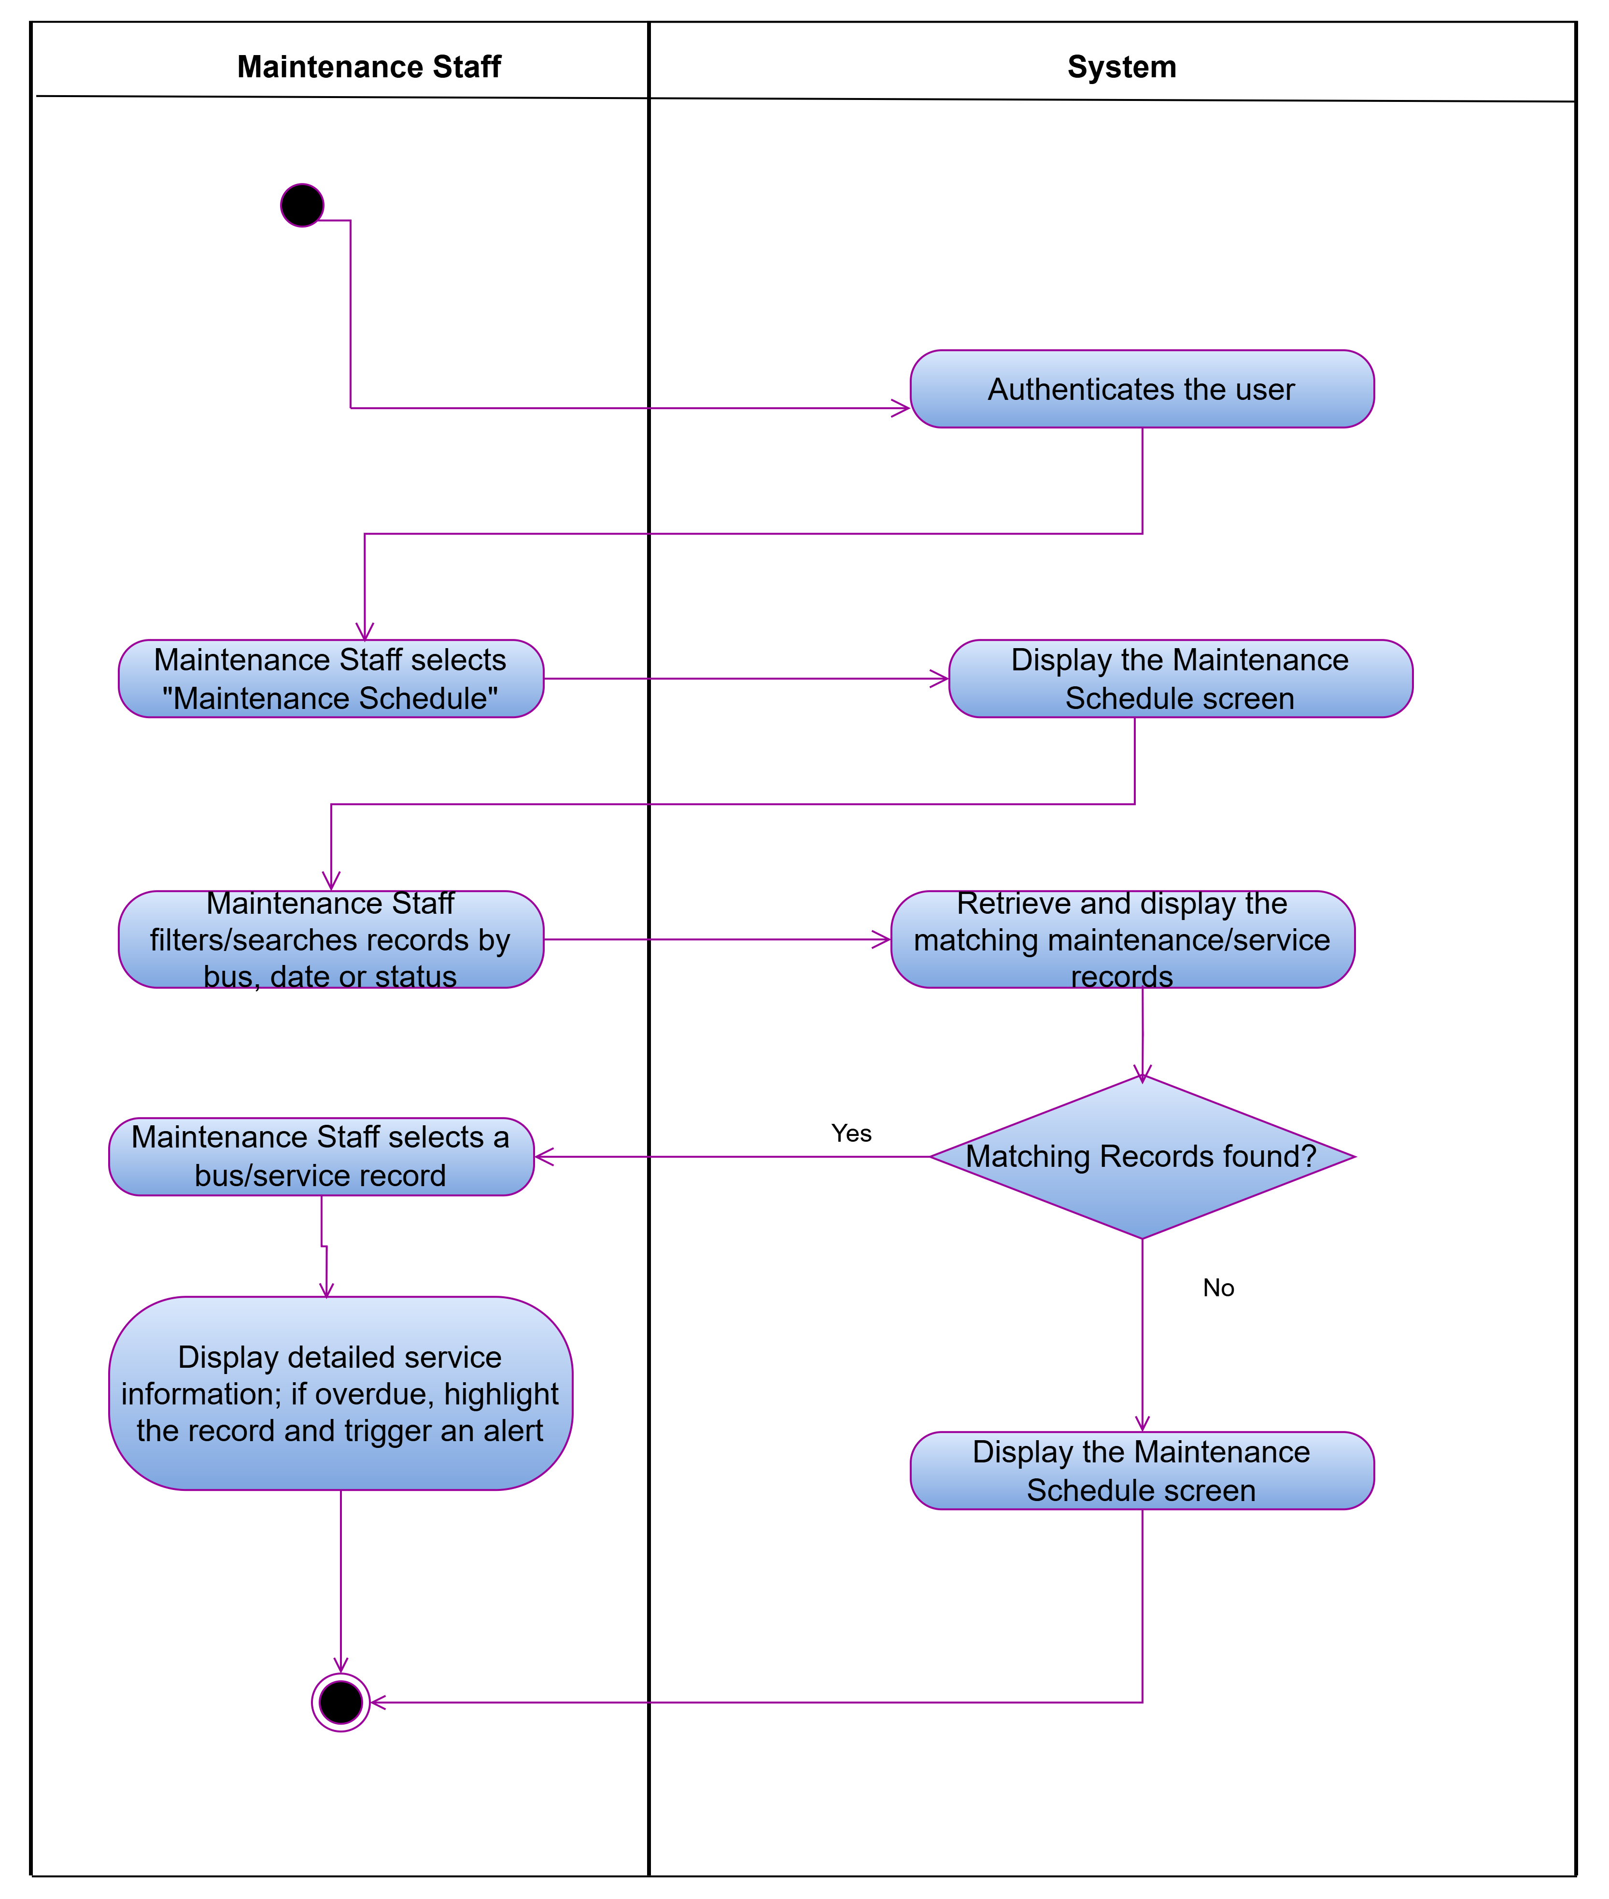
Figure 8 Activity Diagram: UC7 View Maintenance Schedule

1.2.15. Use Case Narrative: Review Fuel
BusNova
Use Case Specification
Use Case Id | UC8
User Case Name | Review Fuel
Actor(s) | Driver
Brief Description | Allows a Driver to review the fuel logs and fuel efficiency information recorded for the bus(es) they operate. The system retrieves the fuel amount, cost, odometer reading and calculated fuel efficiency for each logged entry, allowing the driver to monitor fuel usage and consumption trends over time.
Frequency of use | As needed, typically after each trip or refuelling stop.
Preconditions | 1. The Driver has a registered account and is logged into the system.  2. Fuel logs exist for the bus(es) assigned to the driver.
Main Flow of Events | Actor |  | System
Main Flow of Events | 1. Selects "Review Fuel".  2. Filters or searches fuel records by bus or date.  3. Selects a fuel record to view further details. |  | 1.1 Retrieve and display the fuel logs for the bus assigned to the driver.  2.1 Retrieve and display the fuel records matching the filter criteria.  3.1 Display detailed fuel information.
Alternative Flows of Events | 1. No fuel logs match the filter criteria, The system displays "No fuel records found".
Postconditions | The Driver has reviewed the fuel log and fuel efficiency information. No data is modified by this use case.
Special Requirements | Fuel efficiency must be calculated accurately from the logged fuel amount, cost and distance travelled; fuel log information must reflect the most recently logged records.
Created by | Nadia Mpohlekana | Last Modified by
Date | 22 August 2026 | Date
Table 9 Use Case Narrative: Review Fuel

1.2.16. Activity Diagram: UC8 Review Fuel
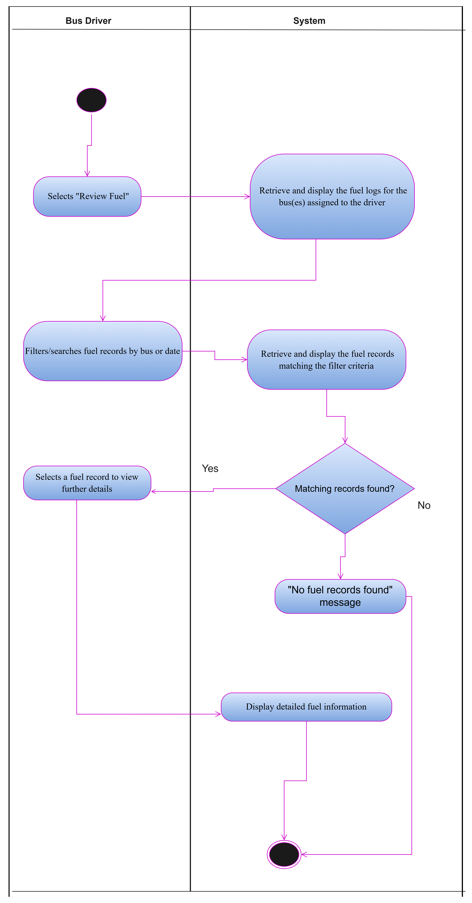
Figure 9 Activity Diagram: UC8 Review Fuel

1.2.19. Use Case Narrative: Monitor Operations
Fleet Management System
Use Case Specification
Use Case Id | UC6
User Case Name | Monitor Operations
Actor(s) | Manager
Brief Description | Allows the Manager to monitor ongoing bus operations in real time from a central dashboard, including vehicle locations, trip progress, delays and driver check-ins.
Frequency of use | High, used throughout the operating day.
Preconditions | Fleet Manager is authenticated. Routes have been assigned and buses are actively operating trips.
Main Flow of Events | Actor |  | System
Main Flow of Events | 1. Navigate to the "Operations Dashboard".  2. Select a specific bus/trip to view further detail. |  | 1.1 Retrieve the real-time status of all active buses and trips  1.2 Display the operations dashboard  2.1 Display detailed status for the selected bus or trip
Alternative Flows of Events | 1. If a bus reports a delay or issue beyond the acceptable threshold, the System highlights the affected bus/trip on the dashboard and notifies the Manager.  2. If there are no active trips at the time of viewing, the System displays a "No active operations" message.
Postconditions | Fleet Manager has an up-to-date view of fleet operations. Delayed or problem trips are flagged for follow-up
Special Requirements | Dashboard data must refresh in near real time; the System must generate alerts for delays or reported issues; the dashboard must remain usable when monitoring multiple simultaneous trips.
Created by | Simanye Siximba | Last Modified by |  | Nadia Mpohlekana
Date | 24 August 2026 | Date |  | 30 August 2026
Table 10 Use Case Narrative: Monitor Operations

1.2.20. Activity Diagram: UC6 Monitor Operations 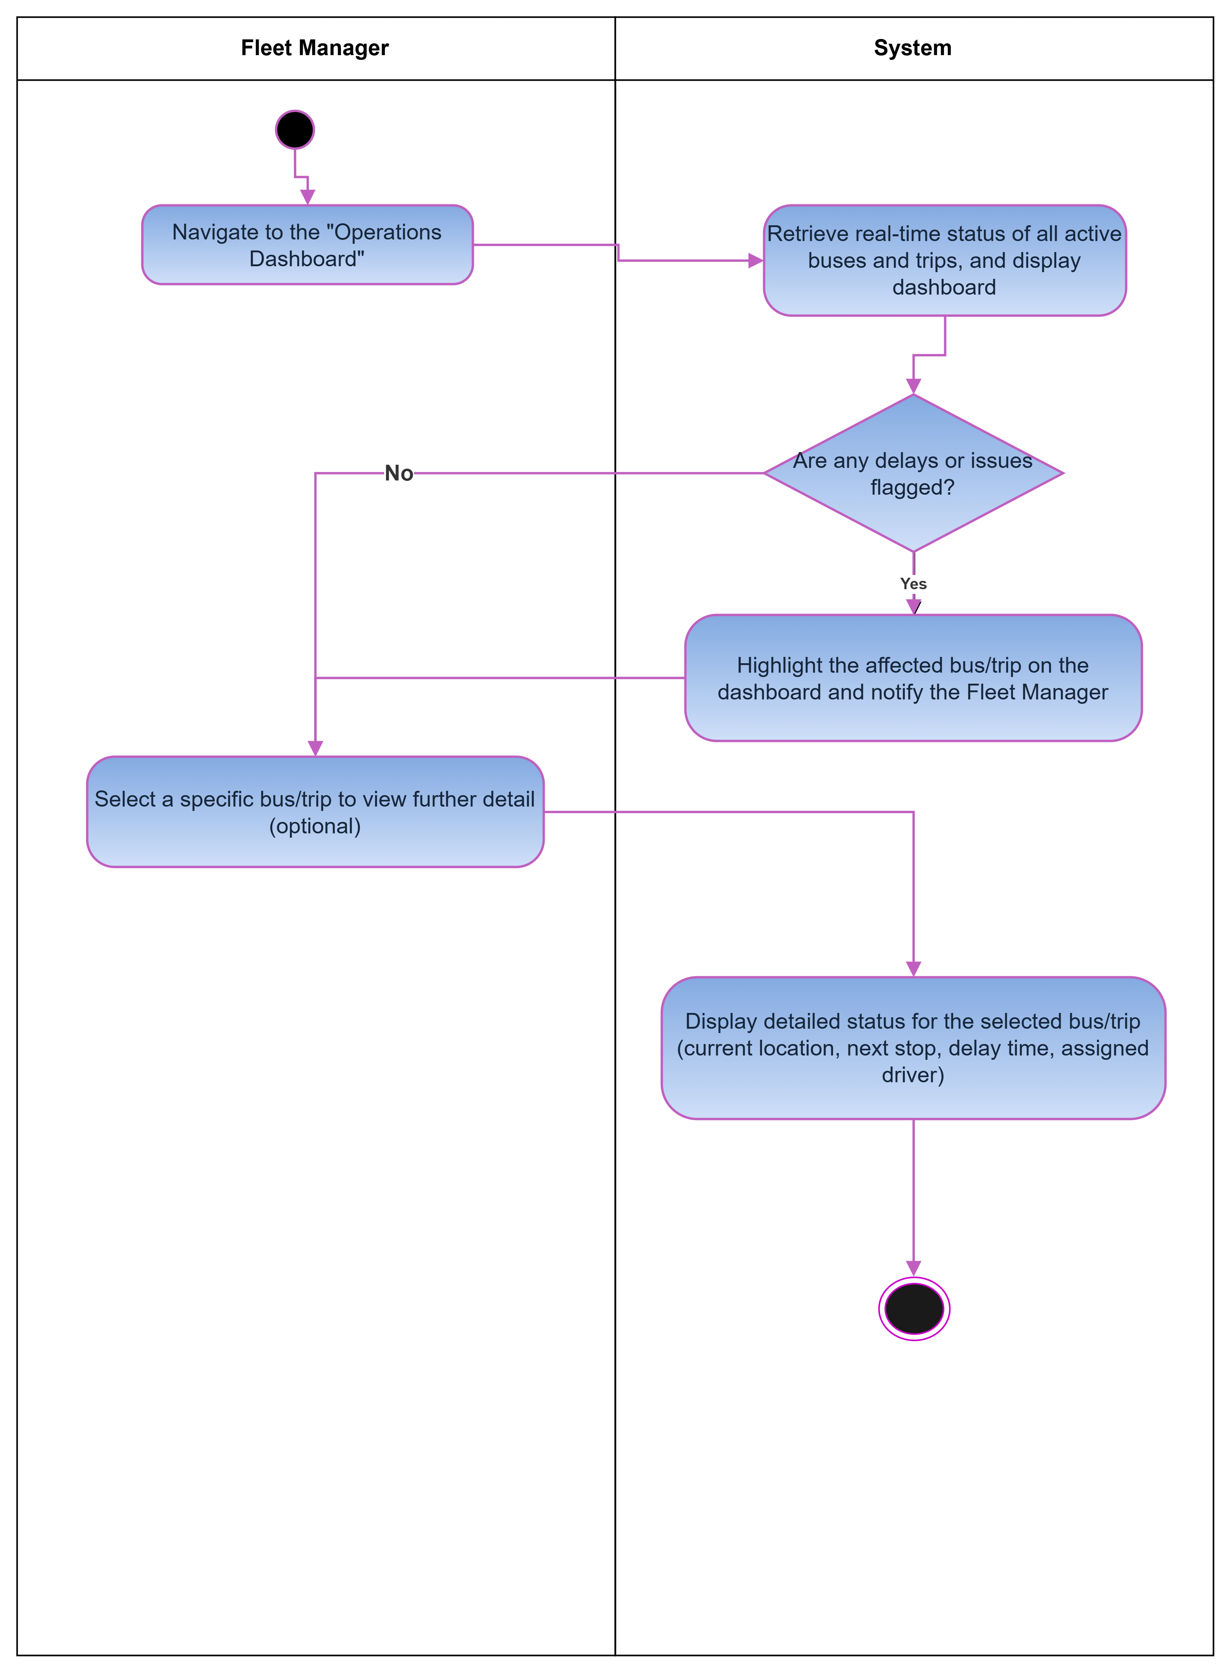
Figure 10 Activity Diagram: UC6 Monitor Operations

1.2.21. Use Case Narrative: View Routes
BusNova
Use Case Specification
Use Case Id | UC13
User Case Name | View Routes
Actor(s) | Passenger
Brief Description | The views available bus routes, departure times, arrival times and trip information
Frequency of use | Whenever a passenger wants to check available bus routes and trip information
Preconditions | Passenger must be logged on to the system
Main Flow of Events | Actor |  | System
Main Flow of Events | 1. Selects “View Routes” |  | 1.1. Redirects user to “View Routes” Page  1.2. Displays available bus routes and trip information
Alternative Flows of Events | If user entered wrong credentials the systems display validation error message on the login screen
Postconditions | The passenger has successfully logged into the system and taken to their dashboard
Special Requirements | Passenger log in details must be valid for them to view available routes
Created by | Olebogeng Gumbu | Last Modified by
Date | 22 August 2026 | Date
Table 11 Use Case Narrative: View Routes

1.2.22. Activity Diagram: UC13 View Routes
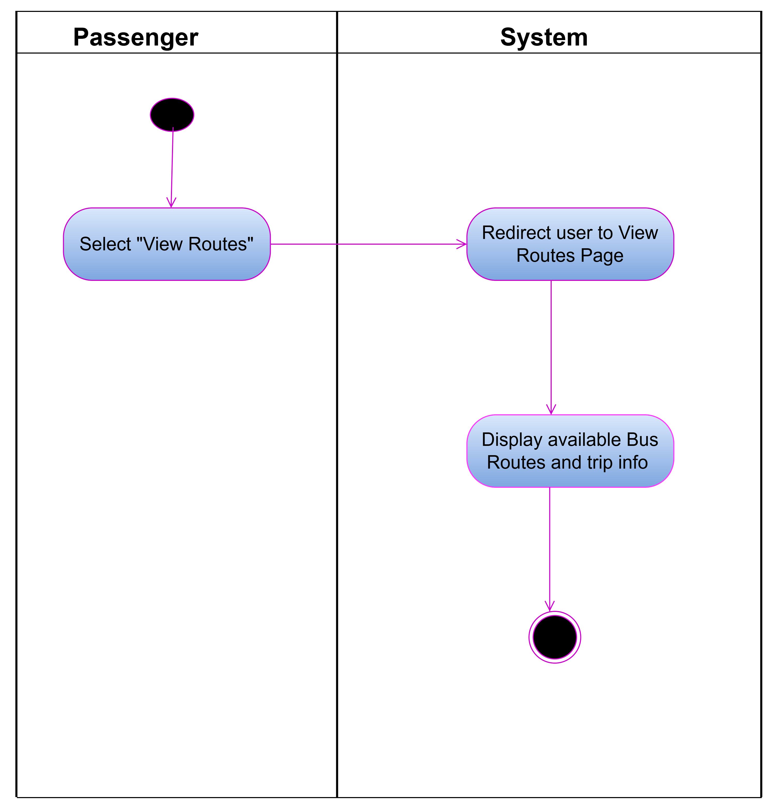
Figure 11 Activity Diagram: UC13 View Routes

1.2.23. Use Case Narrative: Report Fuel
BusNova
Use Case Specification
Use Case Id | UC10
User Case Name | Report Fuel
Actor(s) | Driver
Brief Description | Allows the driver to record the amount of fuel used by the assigned bus after or during a trip. The system stores the fuel usage information for monitoring and reporting.
Frequency of use | Daily after finishing all the trips.
Preconditions | 1. Driver is logged into the system.  2. Driver is assigned to the bus.  3. The bus exists in the system.
Main Flow of Events | Actor |  | System
Main Flow of Events | - Selects ‘Report fuel”.  - Selects the assigned bus.  - Enters fuel usage in litres.  - Enters the trip details.  - Clicks Submit. |  | 1.1 Display fuel reporting form.  5.1 Validates the entered information.  5.2 Saves the fuel usage record.  5.3 Updates the bus fuel usage.  5.4 Displays confirmation message.
Alternative Flows of Events | 1.Fuel usage is missing or invalid, the system displays an error message.  2.The submitted value is unrealistic (e.g., negative) the system requests a valid value.
Postconditions | 1.Fuel usage record is stored.  2.Bus fuel usage history is updated.
Special Requirements | 1. Fuel usage must be entered in litres and must be a positive numerical value.  2. The system must automatically record the date and time of the fuel usage report.  3. The system must identify the logged-in driver and the bus assigned to them.  4. The system must validate all entered information before saving the fuel usage record.  5. Only authorised drivers may submit fuel usage reports.
Created by | Yonwaba Mqulwana | Last Modified by
Date | 24/08/2026 | Date
Table 12 Use Case Narrative: Report Fuel

1.2.24. Activity Diagram: UC10 Report Fuel
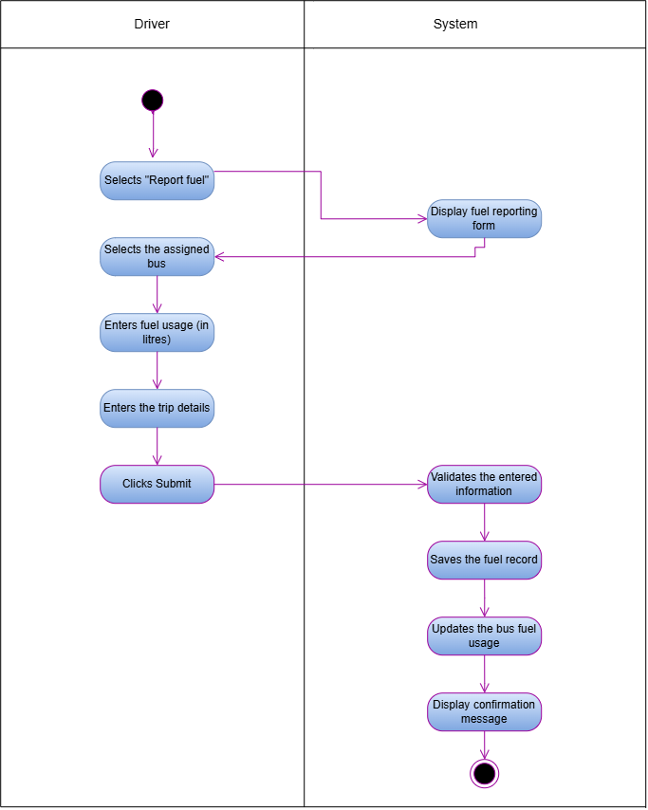
Figure 12 Activity Diagram: UC10 Report Fuel

1.2.25. Use Case Narrative: Log Servicing Activities
BusNova
Use Case Specification
Use Case Id | UC18
User Case Name | Log servicing Activities
Actor(s) | Maintenance staff
Brief Description | Maintenance staff logs details of a completed service/repair on a bus; the system saves the record and updates the bus's service history.
Preconditions | 1.Maintenance staff is registered and logged into the system  2.The bus to be serviced exists in the system.  3.The maintenance staff has been assigned access to the maintenance/service logging module.
Main Flow of Events | Actor |  | System
Main Flow of Events | 1.Selects “Log service activity”  2.Selects the bus that was serviced.  3.Enters the service details  4.Clicks Save Records |  | 1.1. Displays the log service activity form.  2.1. Displays the bus’s maintenance history.  4.1. Validates the required fields.  4.2. Saves the service record to maintenance log.  4.3. Updates the bus’s condition and next service due date.  4.4. Displays a confirmation message: “Service activity logged successfully.”
Alternative Flows of Events | 1. If required fields are missing or invalid, the system displays an error message and returns the maintenance staff to the form.  2. If the next service due date entered is earlier than the service date, the system displays a validation error and prompts for a correct date.
Postconditions | 1. Service record (service type, work carried out, service date, next service due date) is saved to the bus’s maintenance log.  2. Bus's vehicle condition status is updated to reflect the completed service.  3. Bus's next service due date is updated in the system.  4. Confirmation message is displayed.  5. Maintenance history is updated for future reference.
Special Requirements | 1. Required fields must be validated before saving.  2. Next service due date must be later than the service date.  3. Service records must be saved reliably so no data loss.
Created by | Anesipho Kalazana | Last Modified by |  | Yonwaba Mqulwana
Date | 23 August 2026 | Date |  | 25 August 2026
Table 13 Use Case Narrative: Log Servicing Activities

1.2.26. Activity Diagram: UC18 Log Servicing Activities
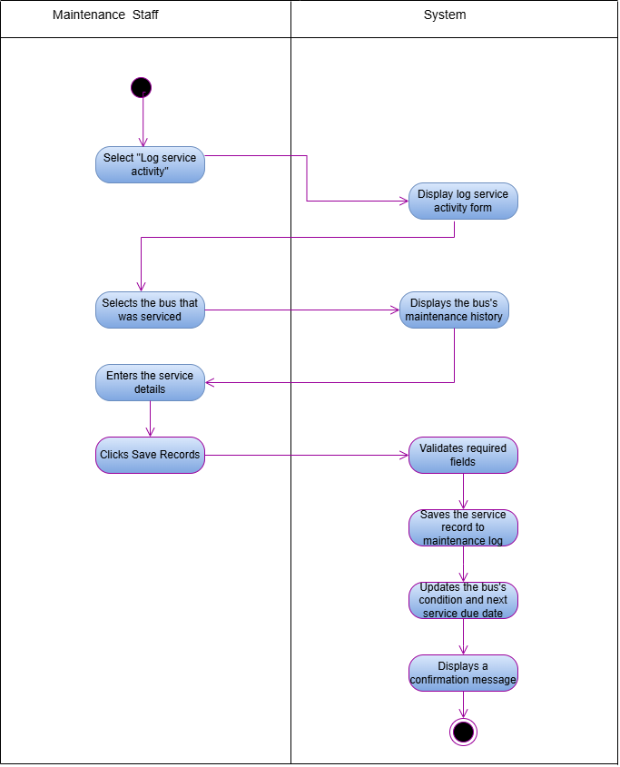
Figure 13 Activity Diagram: UC18 Log Servicing Activities

1.2.27. Use Case Narrative: Purchase Ticket
BusNova
Use Case Specification
Use Case Id | UC15
User Case Name | Purchase Ticket
Actor(s) | Passenger
Brief Description | The passenger picks a route, enters their details, pays and the system checks seat availability, processes the payment and generates the ticket.
Frequency of use | High, whenever a passenger wants to book a trip.
Preconditions | 1.Passenger has a registered account and is logged into the system.  2. The selected route and trip have at least one available seat.
Main Flow of Events | Actor |  | System
Main Flow of Events | 1. Selects a route and checks availability for a trip.  2. Clicks “Purchase Ticket” for the desired trip.  3. Enters passenger details and selects a seat.  4.Enters payment details.  5.Clicks “Pay & Confirm”. |  | 1.1 Displays available trips and seat availability.  2.1. Displays the purchase ticket form.  5.1 Validates the payment details.  5.2 Confirms that the selected seat is still available.  5.3. Processes the payment  5.4. Generates the ticket and saves the record.  5.5. Displays a booking confirmation and sends a confirmation email to the passenger.
Alternative flow of events | 1. If the payment fails, the system displays an error message and prompts the passenger to retry or use a different payment method.  2. If the selected seat becomes unavailable before payment is confirmed, the system notifies the passenger and returns them to seat selection.
Postconditions | A ticket record is created and stored in the database, seat availability for the trip is updated, and the passenger receives a booking confirmation.
Special requirements | Payment details must be processed securely, seat availability must be validated in real time to prevent double booking, and each ticket must be assigned a unique ticket number.
Created by | Anesipho Kalazana | Last Modified by
Date | 24 August 2026 | Date
Table 14 Use Case Narrative: Purchase Ticket

1.2.28. Activity Diagram: UC15 Purchase Ticket
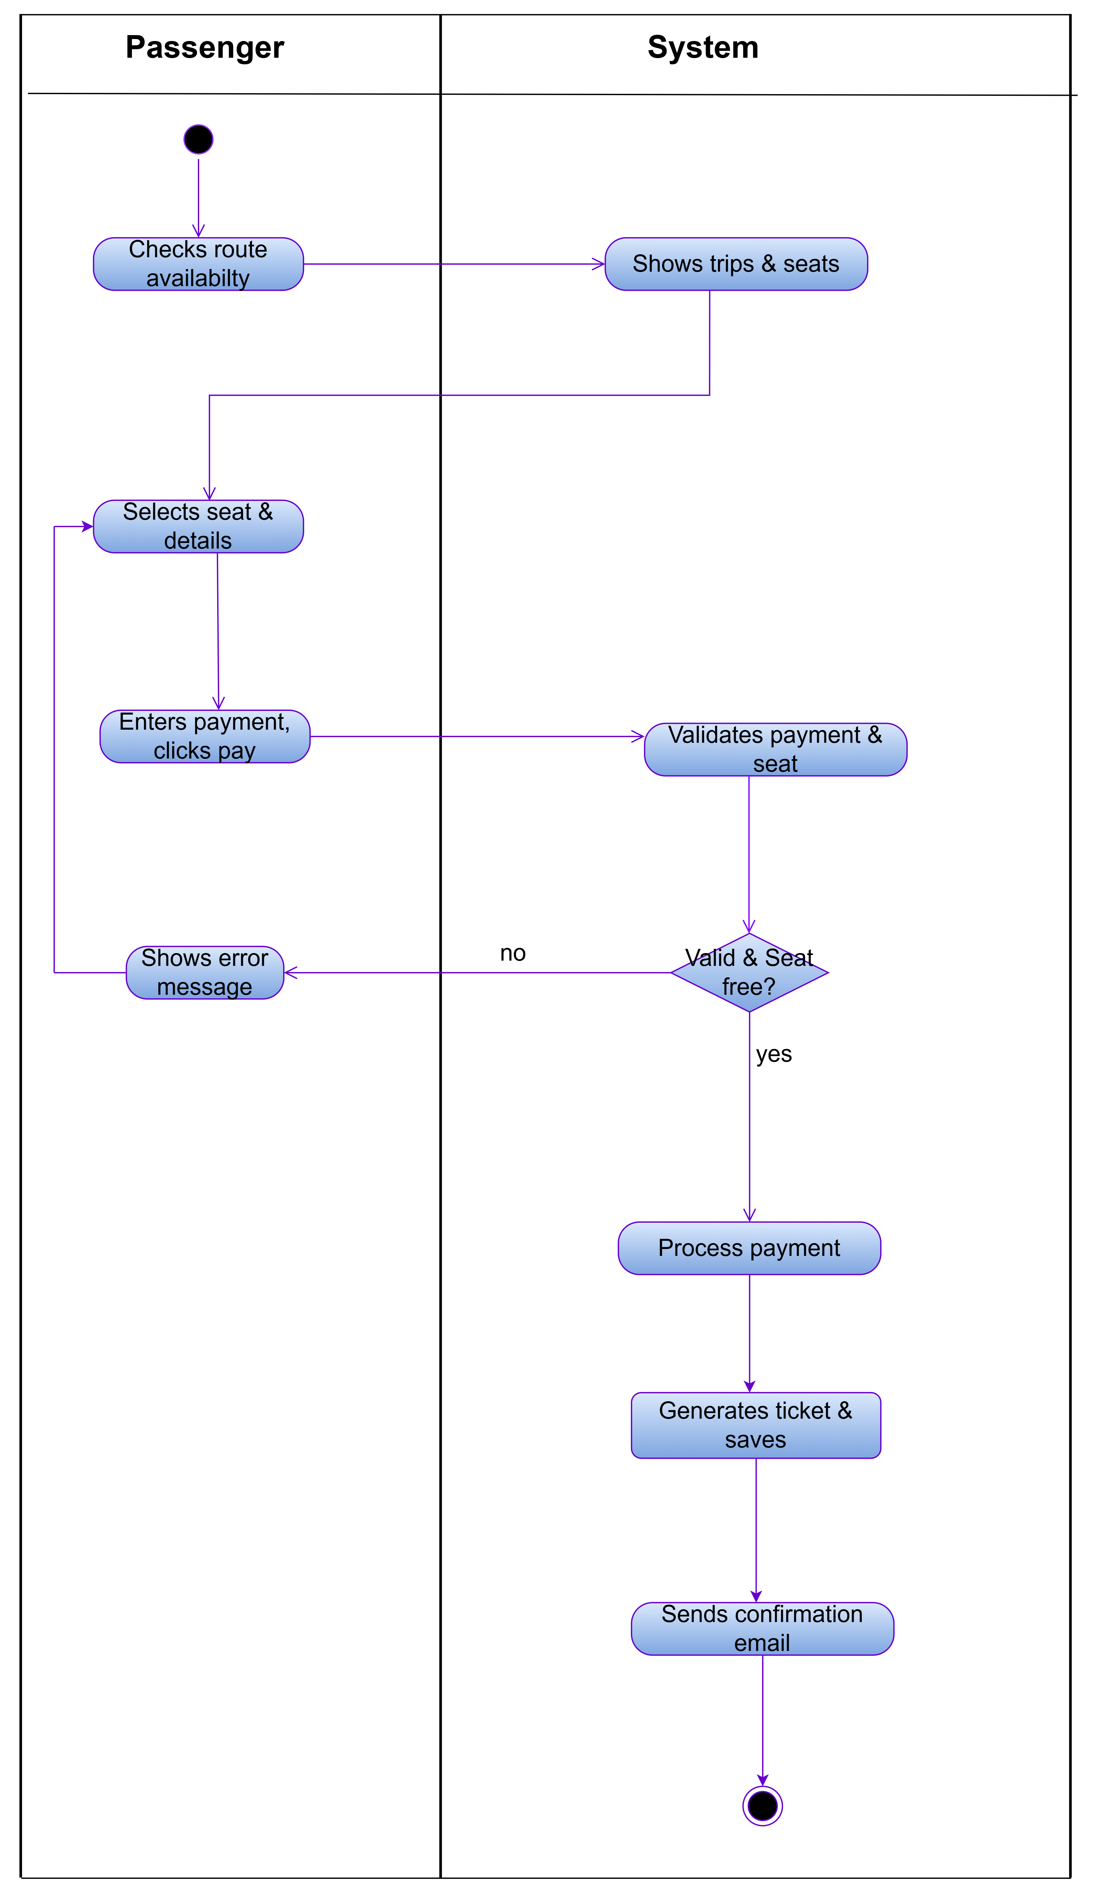
Figure 14 Activity Diagram: UC15 Purchase Ticket

1.2.29. Use Case Narrative: Check availability
Cyber nova
Use Case Specification
Use Case Id | UC14
User Case Name | Check availability
Actor(s) | Passenger
Brief Description | This use case allows a passenger to check the availability of buses by entering the departure location, destination and travel date. The system validates the information, checks available seats and displays the available bus options.
Frequency of use | High, whenever a passenger wants to check available buses before making a booking.
Preconditions | 1. The bus booking system must be available.  2. The passenger must have access to the system.  3. Bus schedules and seat availability must be available in the system.
Main Flow of Events | Actor |  | System
Main Flow of Events | 1. Selects “Check availability”.  2 Enters the departure location, destination and travel date.  3. Views the availability results.  4. Selects an available bus. |  | 2.1 Validate search details  3.1. Displays the book ticket option for an available bus.  4.1. Allows the passenger to proceed to booking.  4.2. Ends the Check availability use case.
  1.1. Displays the search form.
  2.2 Checks the availability of buses and seats
  based on the search details.
Alternative Flows of Events | 1. If invalid details are entered, the system will show an error message and prompt the passenger to correct them.  2. If no seats or no buses are found, the system will display a "No seats available" or "No buses available" message and allow the passenger to search again with new details
Postconditions | 1. Available buses and seats are displayed, allowing the passenger to select a bus and proceed to booking.  2. If no seats or buses are available, the system displays an appropriate message.
Special requirements | 1.The system must verify the departure location, destination, and travel date, provide current, correct bus, and seat availability, and ensure fast search responses.  2. It must also keep passenger details secure during the search and offer a simple, user-friendly experience on all supported devices.
Created by | Esethu Mtose | Last Modified by
Date | 23/08/2026 | Date
Table 15 Use Case Narrative: Check availability

1.2.30. Activity diagram: UC14 Check availability
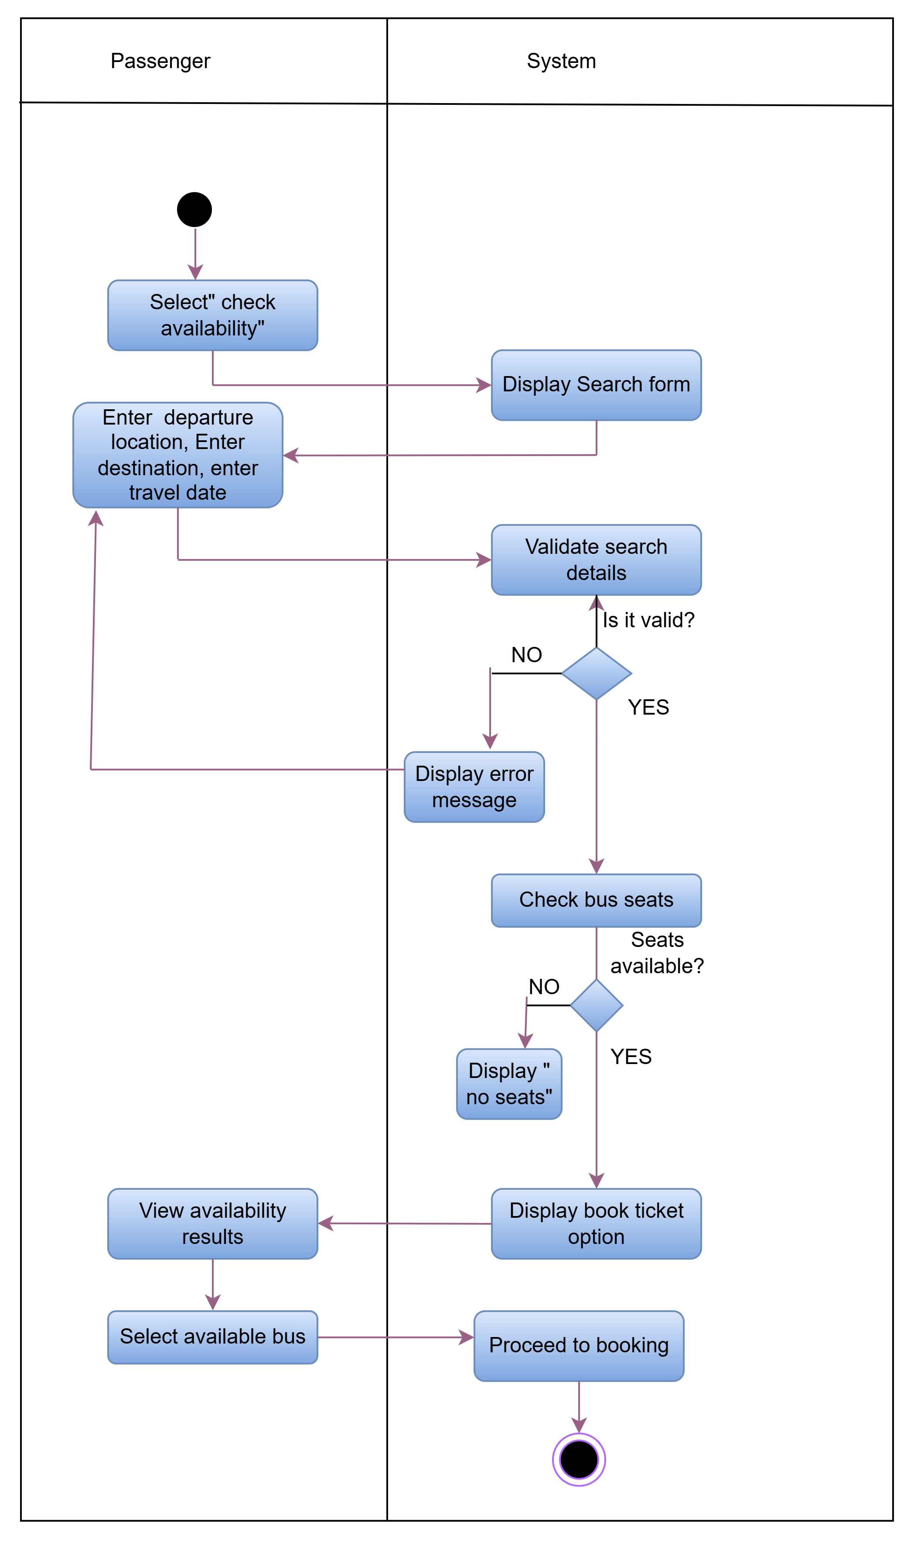
Figure 15 Activity diagram: UC14 Check availability

1.2.31. Use Case Narrative: Report Issues
Bus Nova
Use Case Specification
Use Case Id | UC11
User Case Name | Report Issues
Actor(s) | Driver
Brief Description | The Report Issue use case allows drivers to report problems identified while operating or inspecting a bus. The driver provides information about the issue, such as the bus, issue type, description, and severity. System stores the report in the centralised database and makes the information available to Maintenance Staff for follow-up and maintenance.
Frequency of use | As required, whenever a Bus Driver identifies an issue with an assigned bus. This may occur multiple times per day across the entire fleet, depending on vehicle conditions and operational activities.
Precondition | Driver must be registered in the system.  Driver must be authenticated and logged into the system.  Driver must have an assigned bus.
Main Flow of Events | Actor |  | System
Main Flow of Events | 1. Select “Report issues”  2. Enter the issue details  3. Submit issue |  | - Display Report Form  3.1 Save the issue  3.2 Display Confirmation message
Alternative Flows of Events | The Driver attempts to submit the issue report without completing all required fields.
Postconditions | An issue reference number is generated.  Maintenance Staff can view and manage the reported issue.  The issue status is set to Reported.
Special requirements | Only registered and authenticated Bus Drivers should be allowed to report issues.  The system should prevent loss of issue reports and maintain accurate records even when multiple Drivers are reporting issues simultaneously
Created by | Elihle Nteyi | Last Modified by |  | Yonwaba Mqulwana
Date | 30 August 2026 | Date |  | 30 August 2026
Table 16 Use Case Narrative: Report Issues

1.2.32. Activity Diagram: UC11 Report Issues
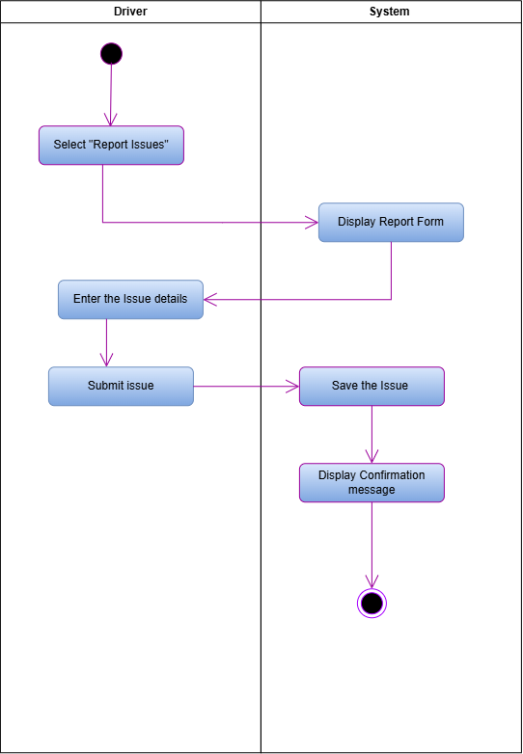
Figure 16 Activity Diagram: UC11 Report Issues

2.Section B: Data Modelling Requirements

2.1. Entity Relationship Diagram
Figure 17 Entity Relationship Diagram

2. 2. Attribute Framing

2.2.1. Employees
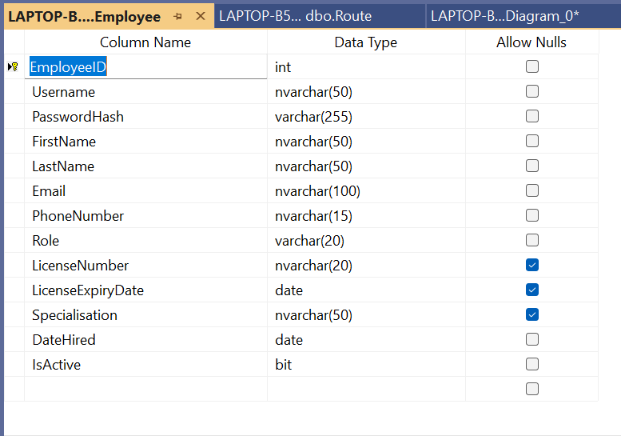
Table 17 Employees

2.2.2. Passengers
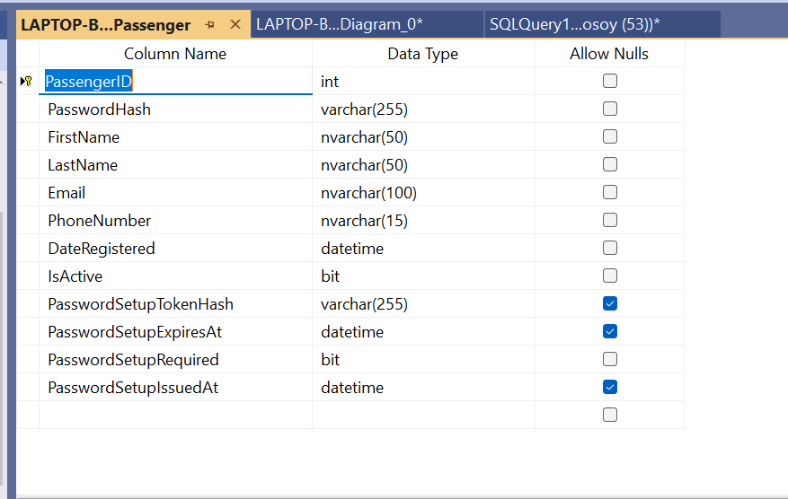
Table 18 Passengers

2.2.3. Bus
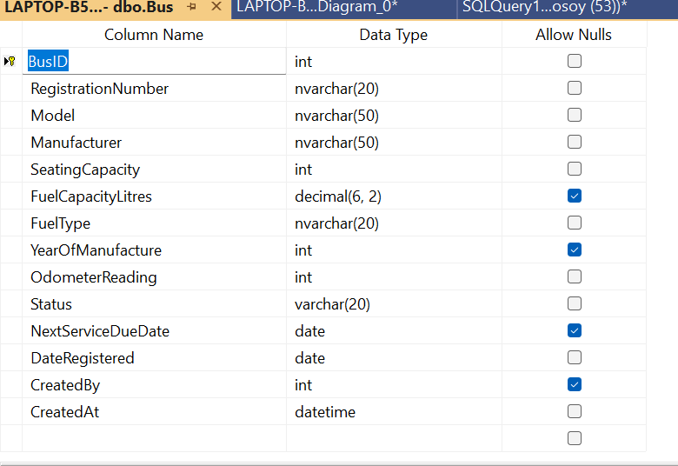
Table 19 Bus

2.2.4. Bus Schedule
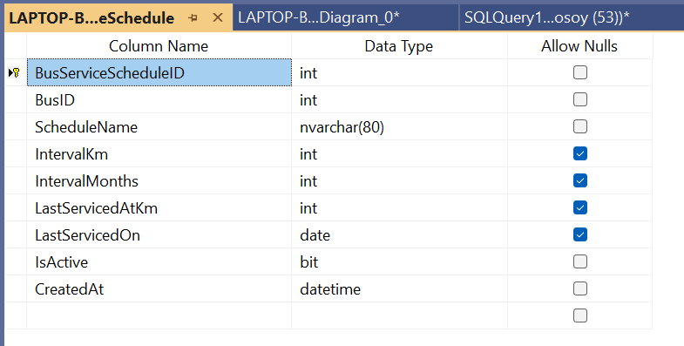
Table 20 Bus Schedule

2.2.5. Route
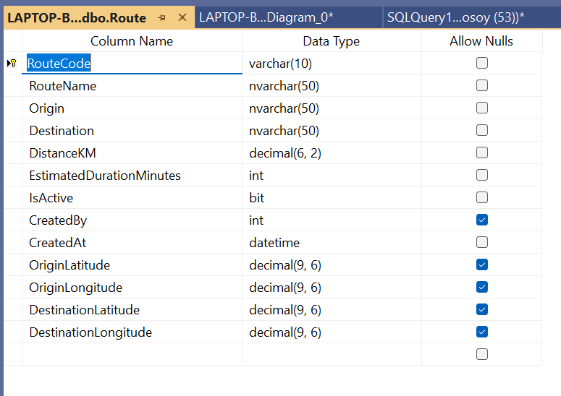
Table 21 Route

2.2.6. Route Assignments
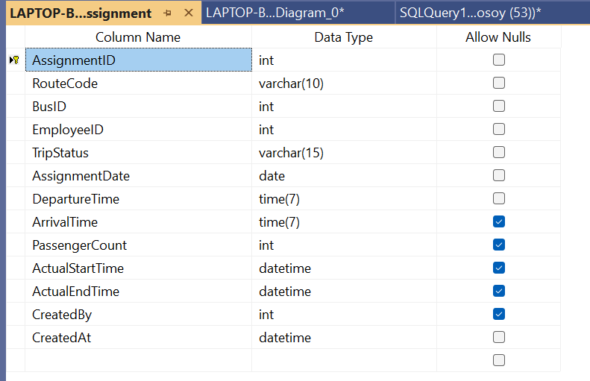
Table 22 Route Assignments

2.2.7. Maintenance Logs
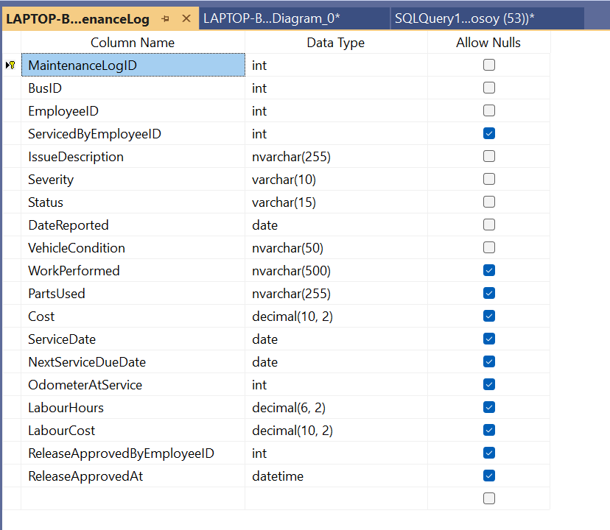
Table 23 Maintenance Logs

2.2.8. Maintenance Parts
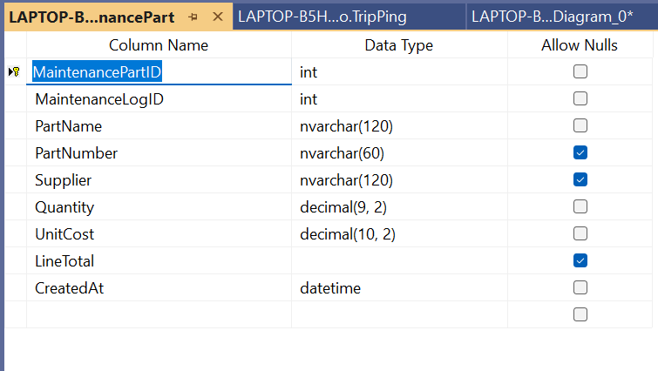
Table 24 Maintenance Parts

2.2.9. Fuel Logs
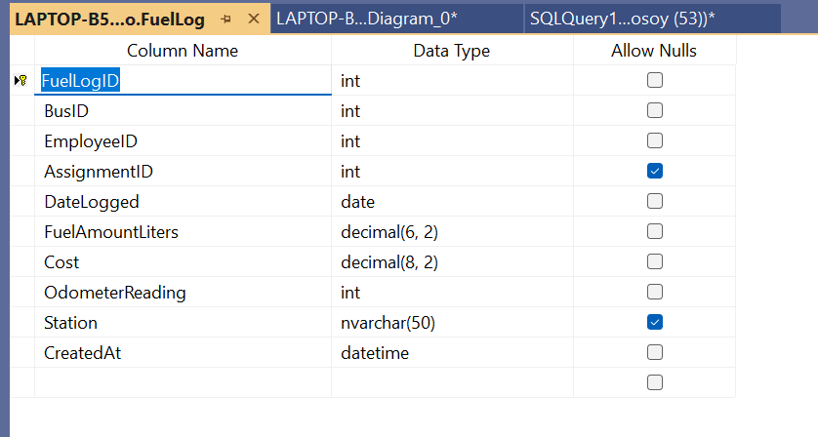
Table 25 Fuel Logs

2.2.10. Tickets
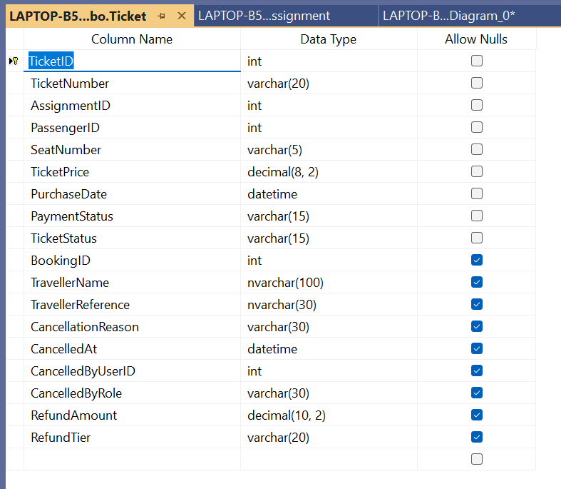
Table 26 Tickets

2.2.11. Tickets Validation
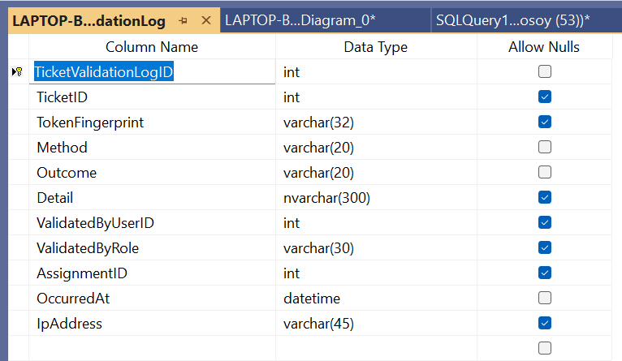
Table 27 Tickets Validation

2.2.12. Booking
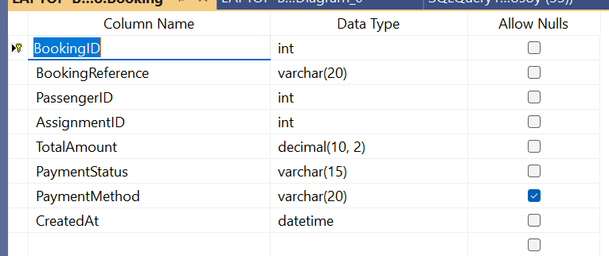
Table 28 Booking

2.2.13. Notification
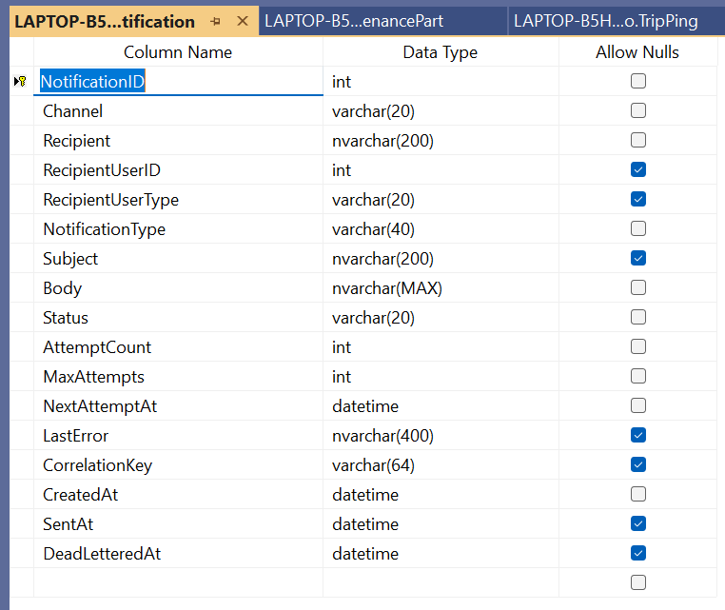
Table 29 Notification

2.2.14. Payment Event
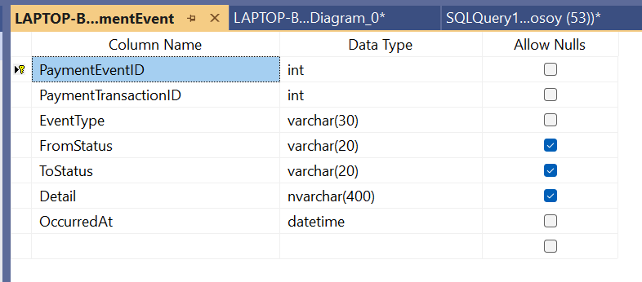
Table 30 Payment Event

2.2.15. Payment Refund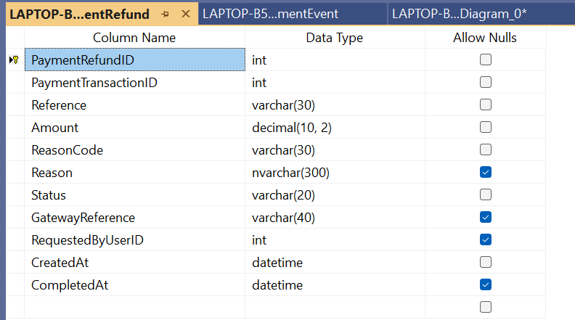
Table 31 Payment Refund

2.2.16. Payment Transaction
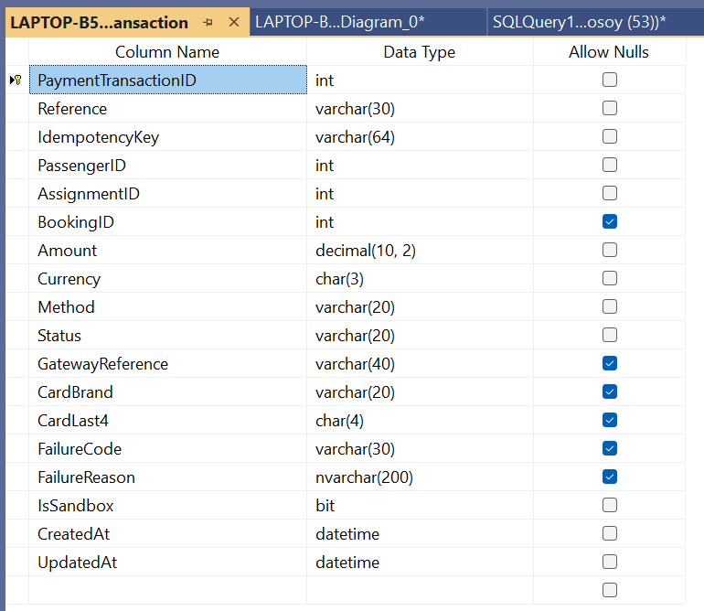
Table 32 Payment Transaction

2.2.17. Audit Logs
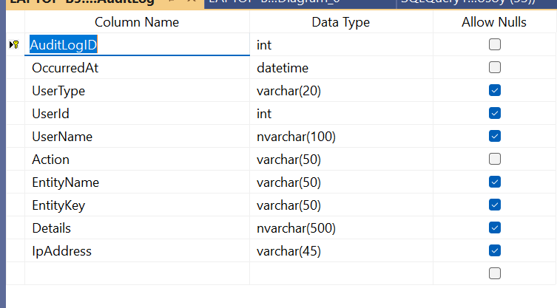
Table 33 Audit Logs

2.2.18. Trip Inspection
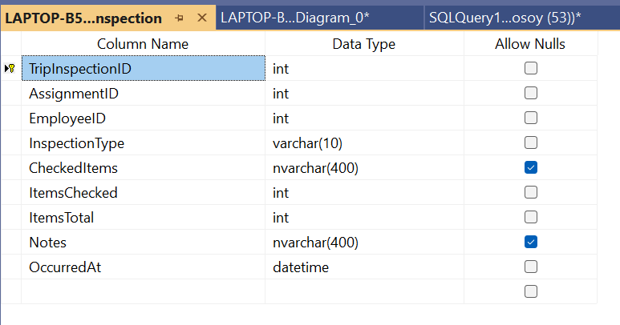
Table 34 Trip Inspection

2.2.19. Trip Pin
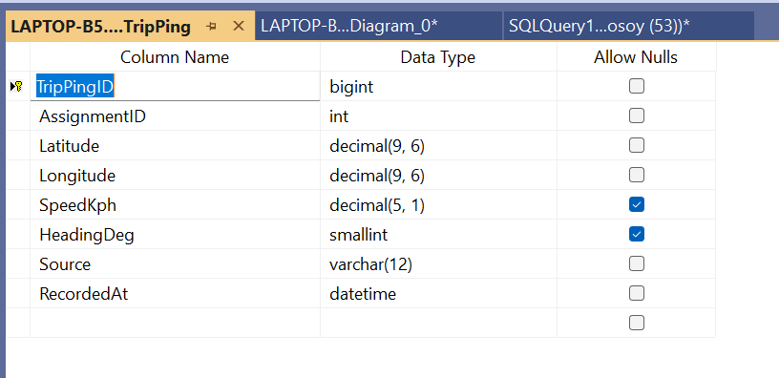
Table 35 Trip Pin

3.Section C: Systems Design Requirements

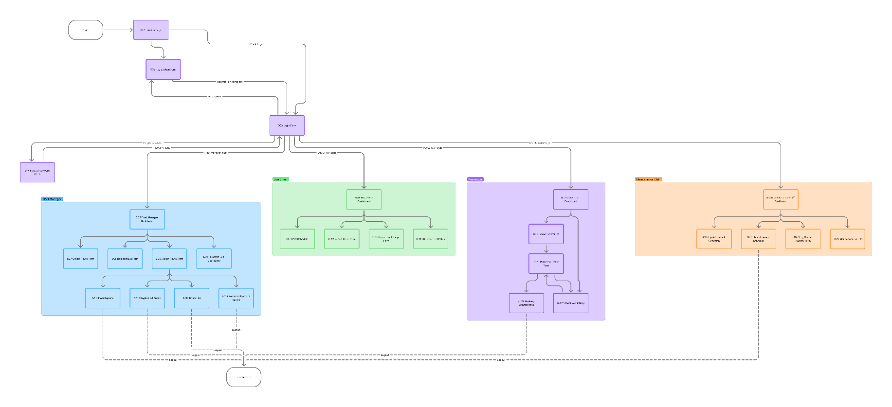
3.1. Windows Navigation Diagram
Figure 18 Windows Navigation Diagram

3.2. Screen Design Specification

3.2.1. Screen 01: Home Page
The Home Page serves as the main entry point to the BusNova System. It introduces users to the system and provides navigation options to access the relevant functionality. Users can select Get Started, Login, or Register to proceed to the appropriate part of the system.
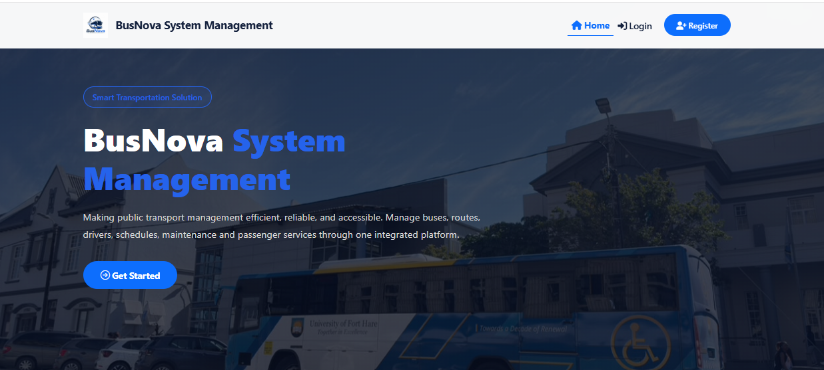
CR4: Button for Login page
CR3: Button for Home page
CR2: Button for Register page
CR1: Button for login page
Figure 19 Screen 01: Home Page

Screen Narrative and Controls: SC1
Reference | Control Type | Data Input | Data Output
CR1 | Button | Click | Login page
CR2 | Button | Click | Register page
CR3 | Button | Click | Home page
CR4 | Button | Click | Login page
Table 36 Screen Narrative and Controls: SC1

3.2.2. Screen 02: Register
The Register screen allows new users to create a BusNova account by entering their personal and account information, including their name, username, email address, contact number and password. The user also selects their appropriate system role during registration. The information provided is used to create the user's account and enable authenticated access to the system.

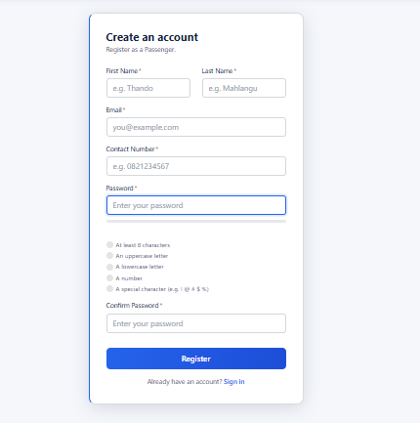
CR8: Button for Register
CR7: Textbox for Confirm Password
CR6: Radio button for verification
CR5: Textbox for Password
CR4: Textbox for Contact Number
CR3: Textbox for Email
CR2: Textbox for Last name
CR1: Textbox for First name
Figure 20 Screen 02: Register

Screen Narrative and Controls: SC2
Reference | Control Type | Data Input | Data Output
CR1 | Textbox | User’s first name
CR2 | Textbox | User’s last name
CR3 | Textbox | User’s email
CR4 | Textbox | Contact details
CR5 | Textbox | User enters password
CR6 | Radio Button |  | Fills up to verify password
CR7 | Textbox | Confirms user’s password
CR8 | Button | Click | Login page
Table 37 Screen Narrative and Controls: SC2

3.2.3. Screen 03: Login
The Login screen allows registered users to securely access the BusNova System by entering their email address and password. Upon successful authentication, the user is directed to the appropriate dashboard based on their assigned role.

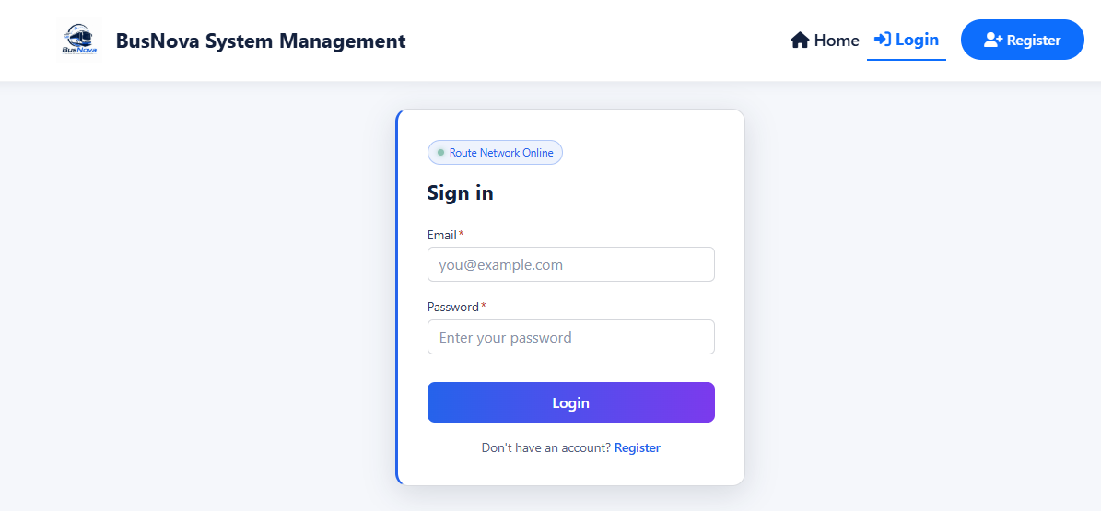
CR2: Button for Login
CR2: Textbox for Password
CR1: Textbox for Email
Figure 21 Screen 03: Login

Screen Narrative and Controls: SC3
Reference | Control Type | Data Input | Data Output
CR1 | Textbox | User’s email
CR2 | Textbox | User enters password
CR3 | Button | Click | Display dashboard
Table 38 Screen Narrative and Controls: SC3

3.2.4. Screen 04: Manager Dashboard
The Manager Dashboard is the operational home page for the Manager role. It consolidates fleet, staffing and ticketing counters into a single decision surface, surfaces urgent items under a "Needs attention" section, and provides direct navigation to the five primary Manager actions. The screen is read-only; all writes occur on the destination pages.
CR7: Card for completed trips
CR6: Card for trips
CR5: Card for active route
CR3: Card for deactivated accounts
CR4: Card for active Bus
CR2: Card for passenger account
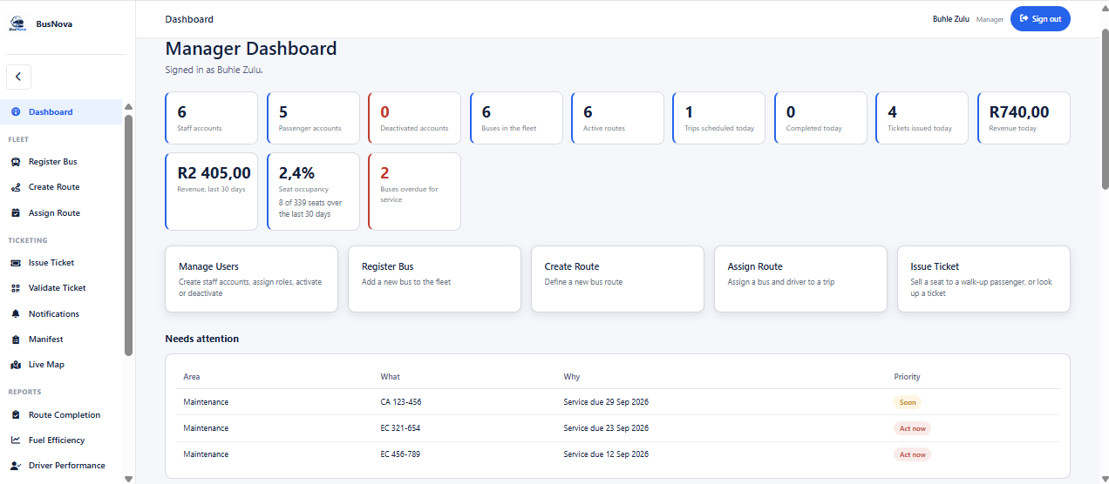
CR16: Card for assigning routes
CR15: Card for creating routes
CR17: Card for creating routes
CR14: Card for registering buses
CR13: Card for manging users
CR11: Card for seat occupancy rate
CR10: Card for total revenue
CR12: Card for buses overdue
CR9: Card for revenue
CR8: Card for tickets booked
CR1: Card for staff account
Figure 22 Screen 04: Manager Dashboard
CR18: Grid view for attention list

Screen Narrative and Controls: SC04
Reference | Control Type | Data Input | Data Output
CR1 | Card |  | Active Staff account
CR2 | Card |  | Active Passenger account
CR3 | Card |  | Deactivated Accounts
CR4 | Card |  | Active Bus
CR5 | Card |  | Active Routes
CR6 | Card |  | Trips Scheduled
CR7 | Card |  | Trips completed
CR8 | Card |  | Tickets Issued
CR9 | Card |  | Revenue generated
CR10 | Card |  | Overall Revenue generated
CR11 | Card |  | Seat Occupancy rate
CR12 | Card |  | Bus Services overdue
CR13 | Card | Click | Manage users page
CR14 | Card | Click | Bus Register page
CR15 | Card | Click | Create Route page
CR16 | Card | Click | Assing Rout page
CR17 | Card | Click | Issue Ticket page
CR18 | Grid view |  | Need attention list
Table 39 Screen Narrative and Controls: SC04

3.2.5. Screen 05: Bus Driver Dashboard
The Bus Driver Dashboard is the operational home page for the Driver role. It shows the driver how many trips are ahead, presents the three actions a driver performs (view schedule, log fuel, report an issue), and lists the next scheduled trips with their status.
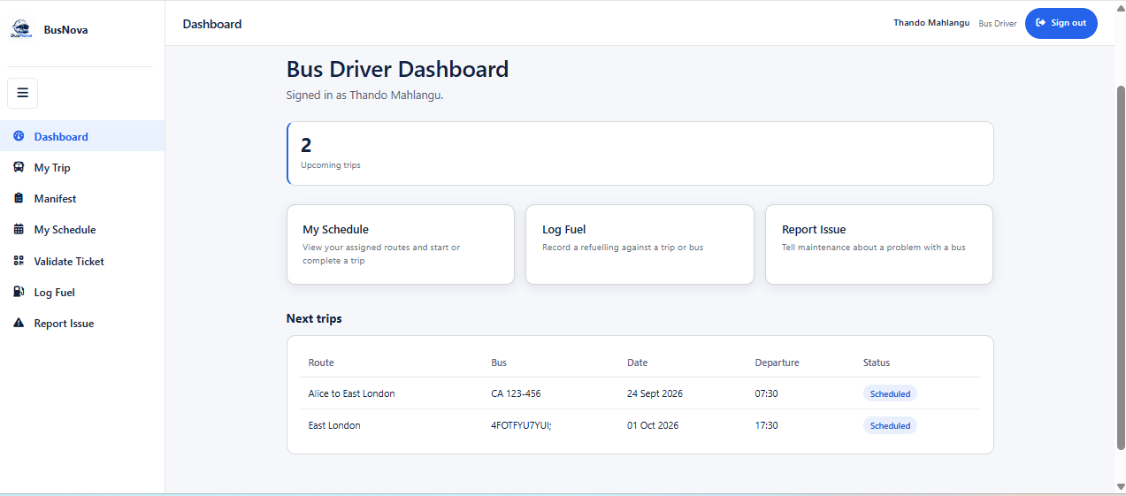
CR6: Pill for trip status
CR5: Grid view for next trip
CR3: Card for Log fuel
CR4: Card for report issue
CR2: Card for viewing schedule
CR1: Card for upcoming trips
Figure 23 Screen 05: Bus Driver Dashboard

Screen Narrative and Controls: SC05
Reference | Control Type | Data Input | Data Output
CR1 | Card |  | Upcoming trips count
CR2 | Card | Click | My Schedule page
CR3 | Card | Click | Log Fuel page
CR4 | Card | Click | Report Issues
CR5 | Grid View |  | Next trips list
CR6 | Pill |  | Trip status
Table 40 Screen Narrative and Controls: SC05

3.2.6. Screen 06: Passenger Dashboard
The Passenger Dashboard is the operational home page for the Passenger role. It provides two paths book a new trip or manage existing tickets and lists the upcoming trips the passenger can travel on, including the number of seats still free on each.

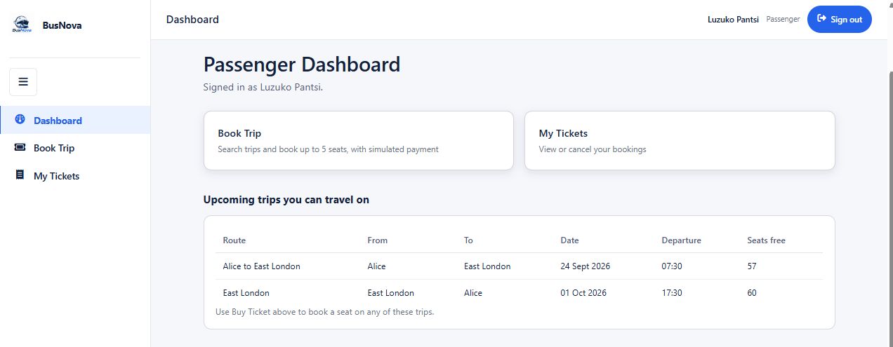
CR1: Card for booking trip
CR2: Card for viewing tickets
CR3: Grid view for viewing upcoming trips
Figure 24 Screen 06: Passenger Dashboard

Screen Narrative and Controls: SC06
Reference | Control Type | Data Input | Data Output
CR1 | Card | Click | Book trip page
CR2 | Card | Click | My Ticket page
CR3 | Grid View |  | Upcoming trips list
Table 41 Screen Narrative and Controls: SC06

3.2.7. Screen 07: Maintenance Staff Dashboard
The Maintenance Staff Dashboard is the operational home page for the Maintenance Staff role. It shows what is overdue for service and what is coming up, links to the maintenance work screen, and lists the buses currently needing attention in urgency order.
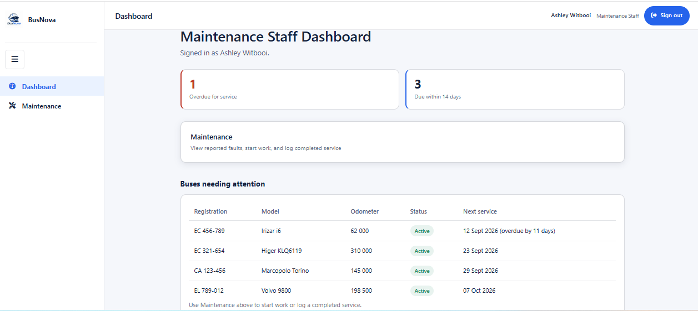
CR4: Gid view for viewing buses needing attention
CR2: Card for viewing services due in 14 days
CR1: Card for viewing overdue services
CR3: Card for viewing maintenances
Figure 25 Screen 07: Maintenance Staff Dashboard

Screen Narrative and Controls: SC07
Reference | Control Type | Data Input | Data Output
CR1 | Grid view | Display assigned route
CR2 | Card |  | Due within 14 days count
CR3 | Card | Click | Maintenance work page
CR4 | Grid View |  | Buses needing attention list
Table 42 Screen Narrative and Controls: SC07

3.2.8. Screen 08: Manage Users
The Manage Users screen allows the Manager to create staff accounts and to activate or deactivate staff and passenger accounts. Staff accounts (Manager, Driver, Maintenance Staff) can only be created here and never from the public Register page; the screen states this explicitly to make the security boundary visible to the operator. 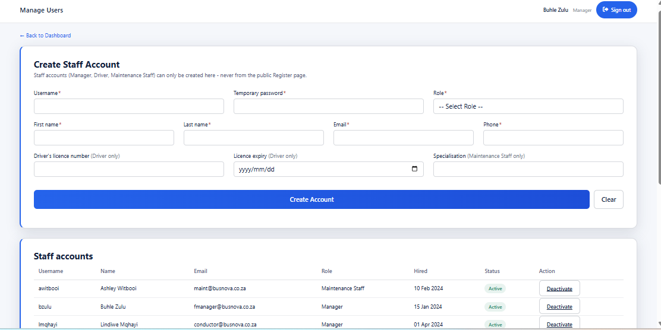
CR4: Textbox for first name
CR5: Textbox for last name
CR1: Textbox for username
CR7: Textbox for phone
CR10: Textbox for specialisation
CR8: Textbox for driver’s license
CR9: Date box for licence expiry
CR6: Textbox for Email
CR2: Textbox for temp password
CR3: Dropdown for role
CR12: Button for clearing form
CR11: Button for creating account
CR14: Button to deactivate an account
CR13: Grid view for staff accounts
Figure 26 Screen 08: Manage Users

Screen Narrative and Controls: SC08
Reference | Control Type | Data Input | Data Output
CR1 | Textbox | Username
CR2 | Textbox | Temporary password
CR3 | Dropdown | Role | Role
CR4 | Textbox | First name
CR5 | Textbox | Last name
CR6 | Textbox | Email
CR7 | Textbox | Phone
CR8 | Textbox | Driver’s licence number
CR9 | Date box | Licence expiry
CR10 | Textbox | Specialization
CR11 | Button | Click | Creates staff account
CR12 | Button | Click | Clear the form
CR13 | Grid view |  | Staff accounts list
CR14 | Button |  | Deactivate staff account
Table 43 Screen Narrative and Controls: SC08

3.2.9. Screen 09: Log Fuel
The Log Fuel screen allows a Driver to record a refuelling event against either a scheduled trip or a bus directly. The date defaults to today, and the trip-or-bus selection is combined in a single dropdown.
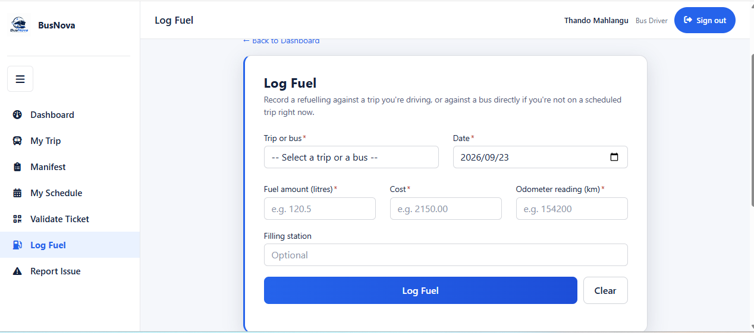
CR4: Textbox for cost
CR6: Textbox for filling station
CR3: Textbox for fuel amount
CR1: Dropdown for trip or bus
CR2: Date box for date of refuelling
CR5: Textbox for odometer
CR8: Button for clearing form
CR7: Button for login fuel
Figure 27 Screen 09: Log Fuel

Screen Narrative and Controls: SC09
Reference | Control Type | Data Input | Data Output
CR1 | Dropdown | Selects trip bus
CR2 | Date box | Date of refueling
CR3 | Textbox | Fuel amount
CR4 | Textbox | Cost
CR5 | Textbox | Odometer
CR6 | Textbox | Filling station
CR7 | Button | Click | Logs the fuel record
CR8 | Button | Click | Clears the form
Table 44 Screen Narrative and Controls: SC09

3.2.10. Screen 10: Report Issue
The Report an Issue screen allows a Driver to report a fault against a bus, creating a maintenance record visible to Maintenance Staff. Selecting a Critical severity takes the bus out of service immediately, which the screen states above the fields.
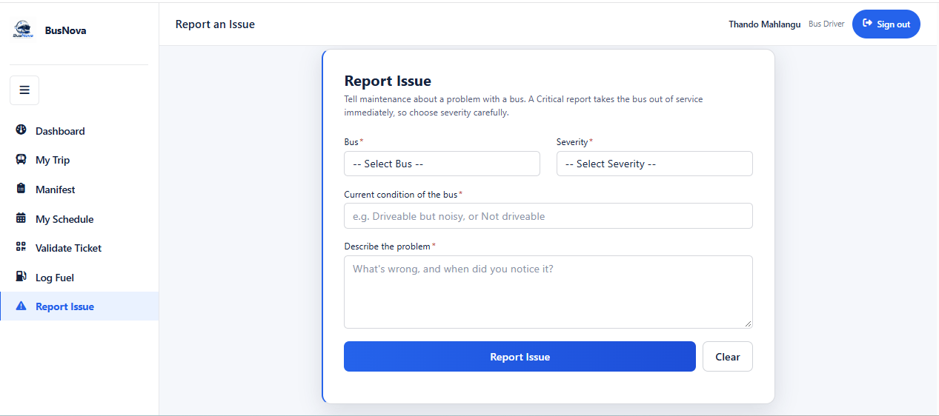
CR6: Button for clearing form
CR2: Dropdown for severity
CR3: Textbox for current condition of bus
CR1: Dropdown for selecting Bus
CR4: Text are for problem description
CR5 Button for issue report
Figure 28 Screen 10: Report Issue

Screen Narrative and Controls: SC10
Reference | Control Type | Data Input | Data Output
CR1 | Dropdown | Selects bus | Bus
CR2 | Dropdown | Select severity | Severity
CR3 | Textbox | Current condition of the bus
CR4 | Text area | Description of the problem
CR5 | Button | Click | Report the issue
CR6 | Button | Click | Clear the form
Table 45 Screen Narrative and Controls: SC10

3.2.11. Screen 11: Register Bus
The Register Bus screen enables the Fleet Manager to add a new bus to the BusNova fleet by capturing details such as the registration number, model, manufacturer, seating capacity, fuel type and year of manufacture. The Register Bus button saves the bus information to the system.
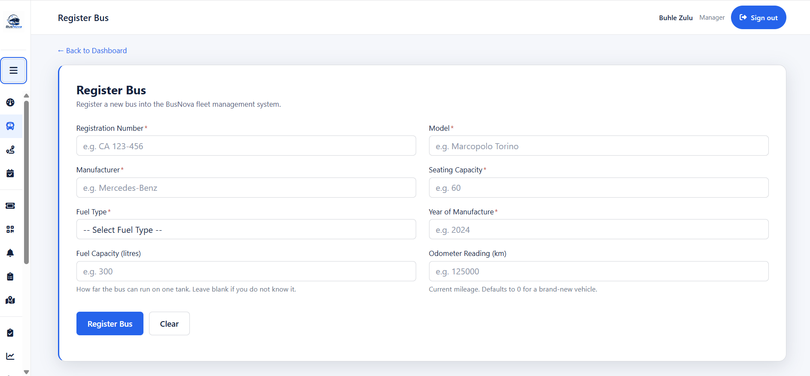
CR2: Textbox for model type
CR1: Textbox for registration number
CR5: Textbox for fuel type
CR3: Textbox for manufacture
CR4: Textbox for seating capacity
CR6: Textbox for year of manufacture
CR10: Button for clearing the form
CR7: Textbox for fuel capacity
CR8: Textbox for Odometer reading
Figure 29 Screen 11: Register Bus
CR9: Button for registering the bus

Screen Narrative and Controls: SC11
Reference | Control Type | Data Input | Data Output
CR1 | Textbox | Registration number
CR2 | Textbox | Bus model
CR3 | Textbox | Bus manufacturer
CR4 | Textbox | Seating capacity
CR5 | Dropdown | Select fuel type | Fuel type
CR6 | Textbox | Year of bus manufacture
CR7 | Textbox | Fuel capacity
CR8 | Textbox | Odometer reading
CR9 | Button | Click | Register bus
CR10 | Button | Click | Clear the form
Table 46 Screen Narrative and Controls: SC11

3.2.12. Screen 12: Create Routes
The Create Route screen enables the Fleet Manager to create a new bus route by entering the required route information, including the route name, origin, destination, distance and estimated travel time. The entered information is submitted to create and store the new route in the system.
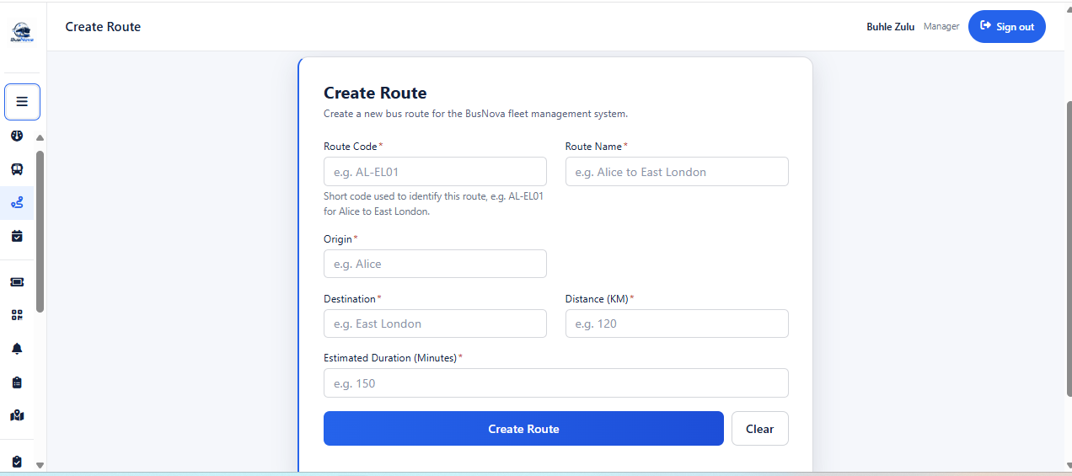
CR5: Textbox for distance
CR8: Button for clearing the form
CR6: Textbox for estimate duration
CR4: Textbox for destination route
CR2: Textbox for route name
CR3: Textbox for origin of route
CR1: Textbox for route code
Figure 30 Screen 12: Create Routes
CR7: Button for creating route

Screen Narrative and Controls: SC12
Reference | Control Type | Data Input | Data Output
CR1 | Textbox | Route code
CR2 | Textbox | Route name
CR3 | Textbox | Origin of route
CR4 | Textbox | Route destination
CR5 | Textbox | Distance in KM
CR6 | Textbox | Estimated duration in minutes
CR7 | Button | Click | Creates route
CR8 | Button | Click | Clear the form
Table 47 Screen Narrative and Controls: SC12

3.2.13. Screen 13: Assign Routes
The Assign Routes screen enables the Fleet Manager to assign an available bus and driver to a selected route and schedule. The Fleet Manager provides the required assignment details, including the route, driver, bus, date and departure information, allowing the system to allocate resources to a specific trip.
CR2: Dropdown for selecting a bus
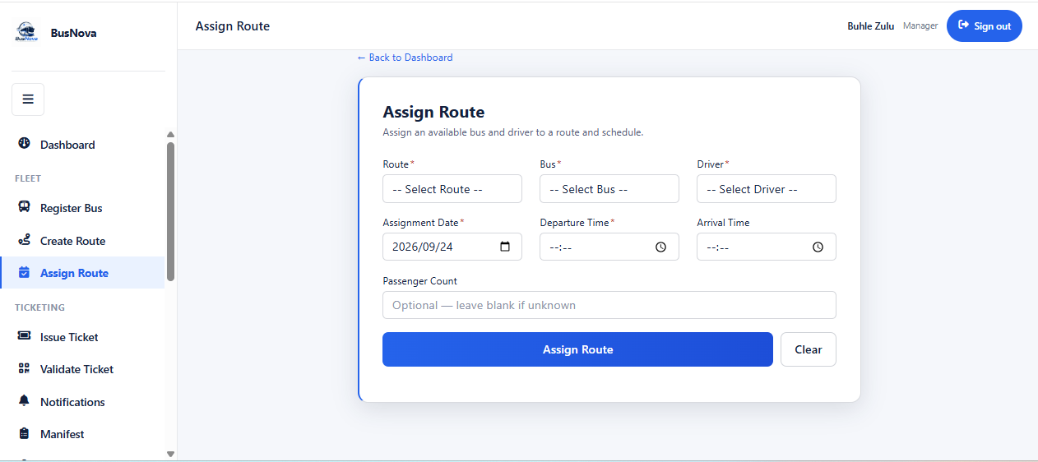
CR1: Dropdown for selecting route
CR4: Dropdown for assignment date
CR5: Textbox for departure time
CR3: Dropdown for selecting a driver
CR6: Textbox for arrival time
CR7: Textbox for passenger count
CR9: Button for clearing the form
CR8: Button for assigning route
Figure 31 Screen 13: Assign Routes

Screen Narrative and Controls: SC13
Reference | Control Type | Data Input | Data Output
CR1 | Dropdown | Select route | Route
CR2 | Dropdown | Select a bus | Bus
CR3 | Dropdown | Select a driver | Driver
CR4 | Dropdown | Assignment date
CR5 | Textbox | Departure time
CR6 | Textbox | Arrival time
CR7 | Textbox | Passenger count
CR8 | Button | Click | Assign route
CR9 | Button | Click | Clear the form
Table 48 Screen Narrative and Controls: SC13

3.2.14. Screen 14: View Assigned Routes
The View Assigned Routes screen allows the Bus Driver to access their assigned routes and trip schedules. It displays important trip information, including the assigned route, bus, date, departure and arrival times, passenger count and current trip status, enabling the driver to monitor their scheduled transportation duties.
CR2: Button to start trip
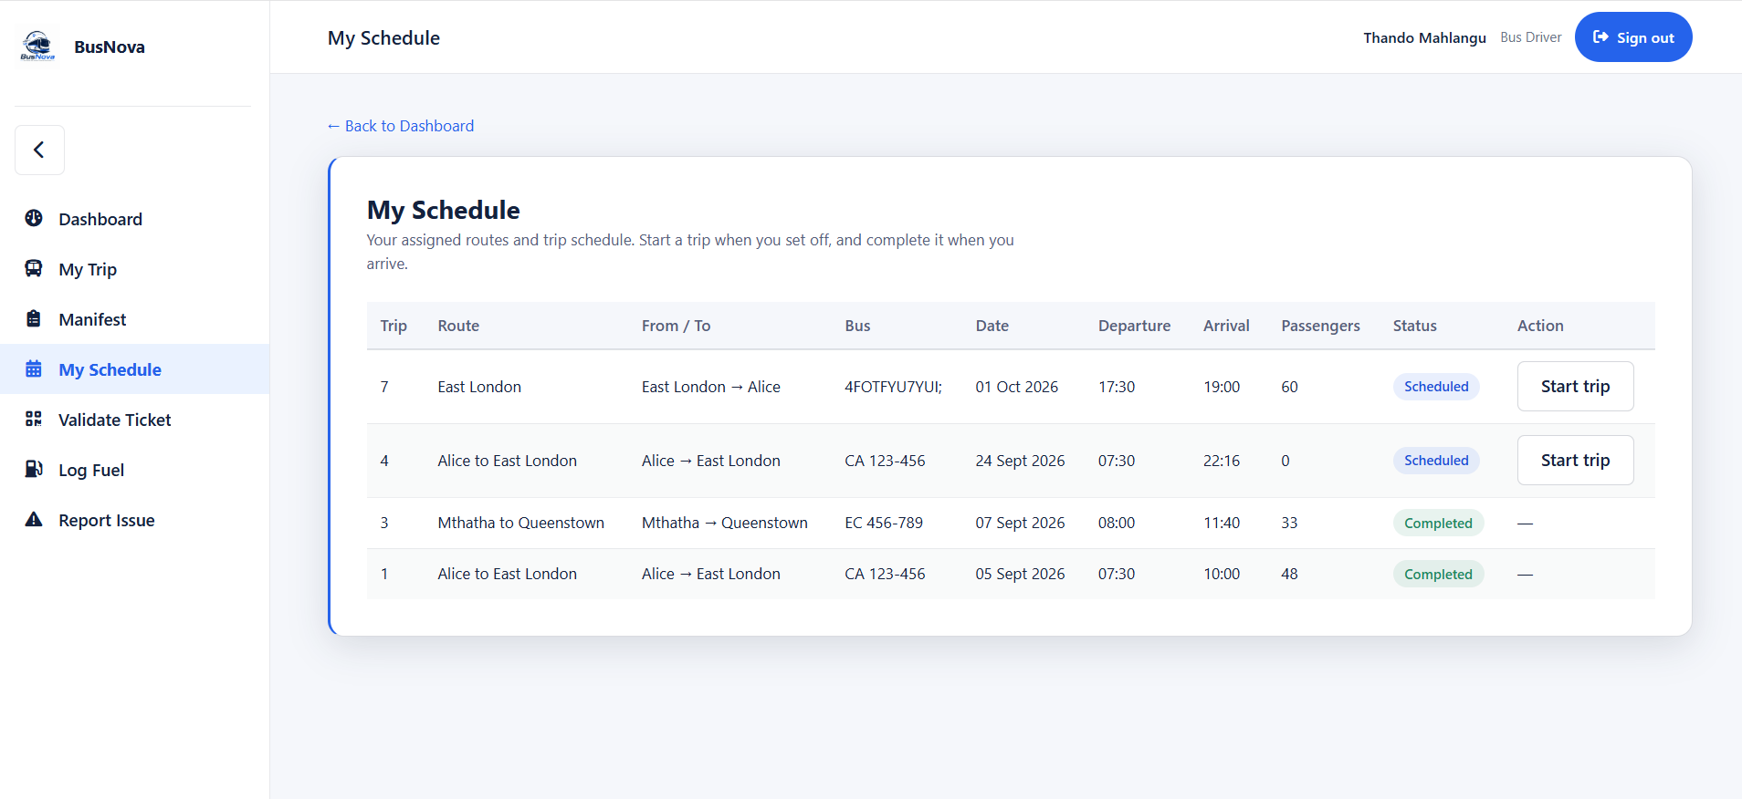
CR3: Pill for status of the trip
CR1: Grid view for viewing route schedule
Figure 32 Screen 14: View Assigned Routes

Screen Narrative and Controls: SC14
Reference | Control Type | Data Input | Data Output
CR1 | Grid view | Display assigned route
CR2 | Button | Click | Starts the trip
CR3 | Pill |  | Status of the trip
Table 49 Screen Narrative and Controls: SC14

3.2.15. Screen 15: Issue Ticket
The Issue Ticket screen allows the Manager to issue a ticket to a passenger at the counter. The Manager selects a date and trip, optionally searches for an existing passenger or registers a new one, picks a seat, and issues the ticket. A separate section on the same page allows an existing ticket to be looked up by number.
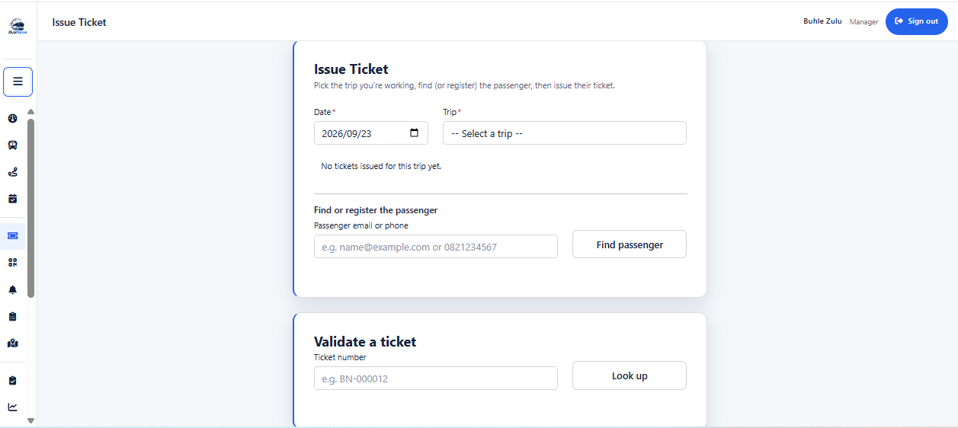
CR1: Card for viewing schedule
CR9: Button for looking ticket
CR8: Textbox for ticket number
CR5:Button to find passenger
CR4: Textbox for email
CR3: Label for ticket count
CR2: Dropdown for trip
CR1: Dropdown for date travel
Figure 33 Screen 15: Issue Ticket

Screen Narrative and Controls: SC15
Reference | Control Type | Data Input | Data Output
CR1 | Dropdown | Date of travel
CR2 | Dropdown | Select trip | Trip
CR3 | Label |  | Ticket count for selected trip
CR4 | Textbox | Passenger email or phone
CR5 | Button | Click | Finds matching passenger
CR6 | Grid view
CR7 | Button | Click | Issues the ticket
CR8 | Textbox | Ticket number
CR9 | Button | Click | Looks up ticket by number
Table 50 Screen Narrative and Controls: SC15

3.2.16. Screen 16: Ticket
The Tickets screen displays the passenger's confirmed tickets as printable e-tickets. Each ticket is a self-contained document carrying the traveller's name, route, travel date, departure time, bus, seat, fare, and a scannable QR code encoding the ticket number and booking reference.
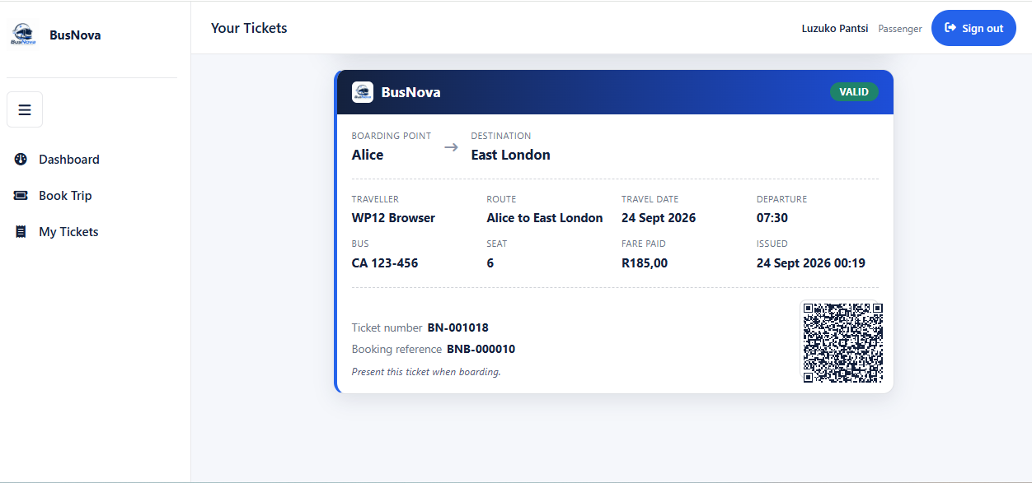
CR2: QR image for bar code
CR1: Card for ticket
Figure 34 Screen 16: Ticket

Screen Narrative and Controls: SC16
Reference | Control Type | Data Input | Data Output
CR1 | Card |  | Ticket details
CR2 | Image (QR) |  | Scannable QR code
Table 51 Screen Narrative and Controls: SC16

3.2.17. Screen 17: Route Completion
The Route Completion report shows how every trip scheduled for a chosen day actually ran — whether it was completed, how late it departed, and how full the bus was. The report includes a calculation note explaining how occupancy and the "carried" figures are derived.2
CR2: Button to run report
CR1: Dropdown list for date
CR9: Card for occupancy rate
CR4: Button to export to CSV
CR3: Button for setting period date
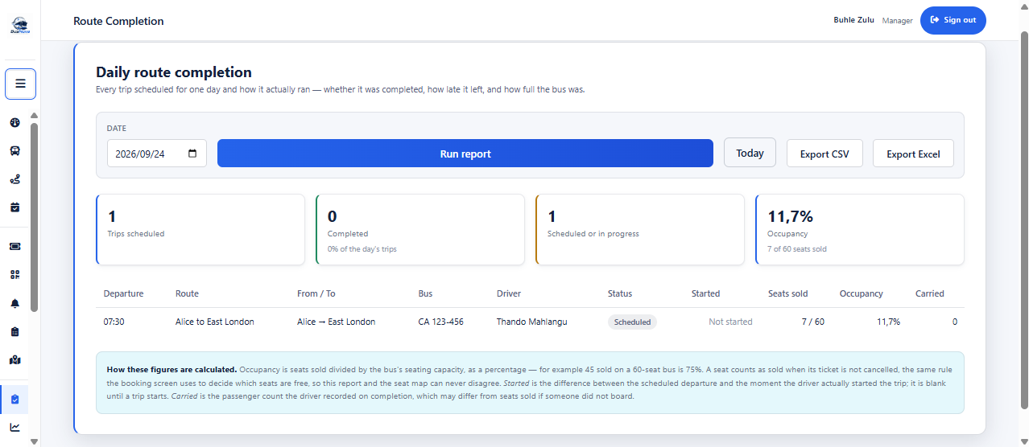
CR10: Grid view for driver’s route
CR6: Card for trip scheduled
CR5: Button for exporting to export excel
CR8: Card for scheduled or in progress
CR7: Card for completed trips
Figure 35 Screen 17: Route Completion

Screen Narrative and Controls: SC17
Reference | Control Type | Data Input | Data Output
CR1 | Dropdown | Date to report on
CR2 | Button | Click | Runs the report
CR3 | Button | Click | Sets period to last 90 days
CR4 | Button | Click | Exports as CSV
CR5 | Button | Click | Exports as Excel
CR6 | Card |  | Trips scheduled count
CR7 | Card |  | Completed count
CR8 | Card |  | Scheduled or in progress count
CR9 | Card |  | Occupancy percentage
CR10 | Grid view |  | Route completion list
Table 52 Screen Narrative and Controls: SC17

3.2.18. Screen 18: Fuel Efficiency
The Fuel Efficiency report shows consumption and running cost per bus over a chosen period, so that a vehicle drinking more fuel than it should is visible before the fuel bill arrives. Where a bus has too few fills in the period to compute a meaningful figure, the report displays "Not enough data" rather than a misleading zero.
CR1: Dropdown list for from date
CR11: Grid view for driver’s performance
CR9: Card for distance covered
CR8: Card for total fuel spending
CR7: Card for Liters purchased
CR10: Card for fleet average
CR5: Button to export to CSV
CR4: Button for setting period date
CR3: Button to run report
CR2: Dropdown list for to date
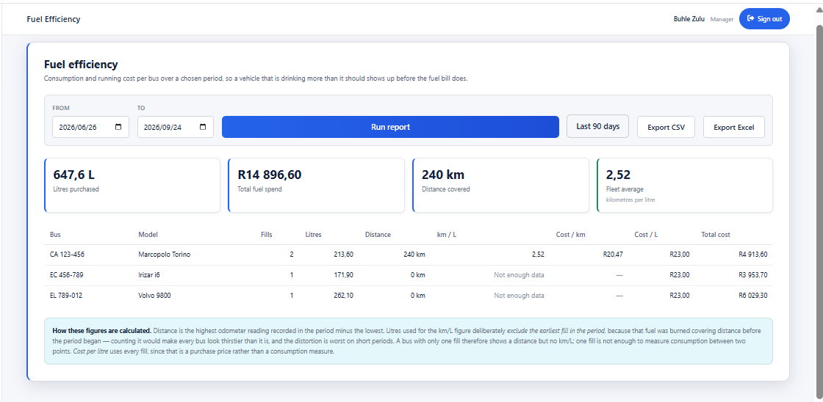
CR6: Button for exporting to export excel
Figure 36 Screen 18: Fuel Efficiency

Screen Narrative and Controls: SC18
Reference | Control Type | Data Input | Data Output
CR1 | Dropdown | From date
CR2 | Dropdown | To date
CR3 | Button | Click | Runs the report
CR4 | Button | Click | Sets period to last 90 days
CR5 | Button | Click | Exports as CSV
CR6 | Button | Click | Exports as Excel
CR7 | Card |  | Litres purchased
CR8 | Card |  | Total fuel spending
CR9 | Card |  | Distance covered
CR10 | Card |  | Fleet average (km/L)
CR11 | Grid view |  | Per-bus fuel efficiency list
Table 53 Screen Narrative and Controls: SC18

3.2.19. Screen 19: Driver Performance
The Driver Performance report shows trips run, punctuality, passengers carried and faults reported per driver over a chosen period. Licence expiry is shown alongside, because a driver who cannot legally drive next month is a scheduling problem this month.
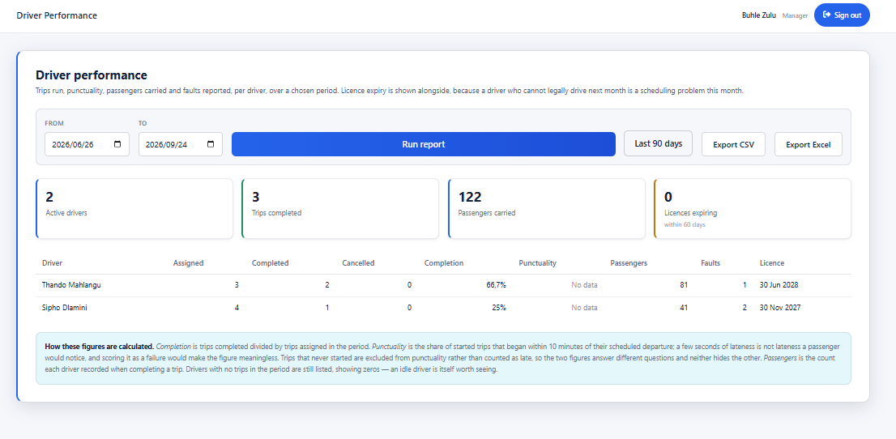
CR10: Card for licences expiring
CR6: Button for exporting to export
CR11: Grid view for driver’s performance
CR9: Card for passengers carried
CR8: Card for trips completed
CR7: Card for active drivers
CR5: Button to export to CSV
CR4: Button for setting period date
CR3: Button to run report
CR2: Dropdown list for to date
CR1: Dropdown list for from date
Figure 37 Screen 19: Driver Performance

Screen Narrative and Controls: SC19
Reference | Control Type | Data Input | Data Output
CR1 | Dropdown | From date
CR2 | Dropdown | To date
CR3 | Button | Click | Runs the report
CR4 | Button | Click | Sets period to last 90 days
CR5 | Button | Click | Exports as CSV
CR6 | Button | Click | Exports as Excel
CR7 | Card |  | Active driver count
CR8 | Card |  | Trips completed count
CR9 | Card |  | Passengers carried count
CR10 | Card |  | Licenses expiring withing 60 days
CR11 | Grid view |  | Per-driver performance
Table 54 Screen Narrative and Controls: SC19

3.2.20. Screen 20: Maintenance Due
The Maintenance Due report lists every bus in the fleet in urgency order, combining scheduled service dates with any open critical faults. An open critical fault takes precedence over an overdue service, because an unsafe bus should not be running and a merely late one can be. The report is a snapshot of now and has no date filter by design.
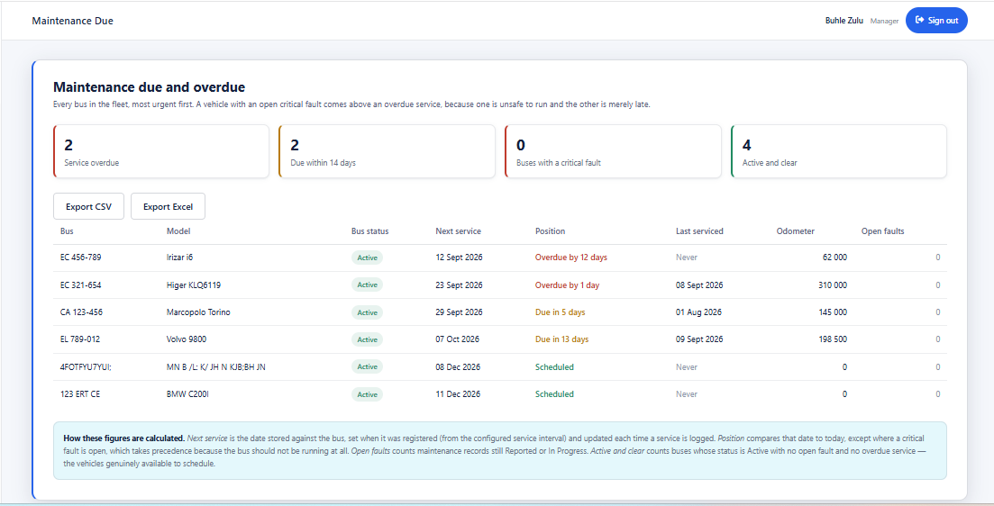
CR7: Grid view for fleet maintenance
CR6: Button for exporting to Excel
CR5: Button for exporting to CSV
CR4: Card for buses active
CR3: Card for buses in critical fault
CR2: Card for service due within 14 days
CR1: Card for service overdue
Figure 38 3.2.20. Screen 20: Maintenance Due

Screen Narrative and Controls: SC20
Reference | Control Type | Data Input | Data Output
CR1 | Card |  | Service overdue count
CR2 | Card |  | Due within 14 days count
CR3 | Card |  | Buses with a critical fault count
CR4 | Card |  | Active and clear count
CR5 | Button | Click | Exports as CSV
CR6 | Button | Click | Exports as Excel
CR7 | Grid view |  | Fleet maintenance list
Table 55 Screen Narrative and Controls: SC20

Sprint Backlog - Sprint 1
Requirement | Sub Tasks | Dependency | Estimated  Completion  Time (in days) | Responsible  Group Member
1.Business  Process  Description | 1.1 Identify actors and business processes | none | 1 day | Nadia  Mpohlekana
 | 1.2 Create  System Matrix | Identify actors and business processes | 1 day | Olebogeng  Gumbu
 | 1.3 Develop Use  Cases | Create System  Matrix | 2 days | Esethu Mtose
 | 1.4 Write Use  Narratives | Developed use cases | 2 days | Anesipho  Kalazana
 | 1.5 Create  Activity  Diagrams | Use Case  Narratives | 2 days | Yonwaba  Mqulwana
2.Data  Modelling | 2.1Identify entities and attributes | System matrix | 1 day | Elihle Nteyi
 | 2.2 Create ERD | Entity identification | 2 days | Esethu Mtose
 | 2. 3 Create  Attribute  Framing | ERD complete | 1 day | Olebogeng  Gumbu
 | 2.4 Generate  SQL database creation script | Attribute framing complete | 2days | Nadia  Mpohlekana
3.System Design requirements | 3.1UML Window  Navigation  Diagram | Activity Diagrams completed | 2 days | Elihle Nteyi
 | 3.2 Screenshots | UML Window  Navigation  Diagram | 1 day | Simanye  Siximba
 | 3.3 Screen narratives and controls | System Screens (Screenshots) completed | 1 day | Simanye  Siximba
4.Documentation | Review sprint 1 document | All tasks completed | 3 days | All members

Risk Log

Ref  No | Description | SQERT | Probability | Impact | Criticality | Proximity | Author | Mitigation  and owner | Date  Raised | Date  Updated | Current  Status | Date  Closed
1 | Database changes made by one team member causing compatibility problems for other team members | ST | 3 | 4 | 12 | During collaborative development | Team Members | DB Developer | 31/07/2026 | 08/08/2026 | Reducing | Not closed
2 | Insufficient system testing before submission | T | 3 | 5 | 15 | During final testing | Team Members | Testing Member | 01/08/2026 | 08/08/2026 | New | Not closed
3 | Loss or corruption of project files or database due to inadequate backups | QER | 2 | 5 | 10 | Throughout development | Team Members | Technical Lead | 02/08/2026 | 08/08/2026 | Reducing | Not closed

KEY: SQUERT
Code | Meaning
S | Scope
Q | Quality
E | Effort
R | Resources
T | Time

Sprint Progress Report
Project Name:  BusNova Bus Management System | Sprint Number:  Sprint 1
Sprint Duration:  13 July 2026 - 11 August 2026 | Report Date:  11 August 2026
Report Number:  1 | Prepared By:  Nadia Mpohlekana

Sprint Goals | Goal 1: Analyse the business processes of the BusNova system and finalise the functional and non-functional requirements.  Goal 2: Produce a complete UML design blueprint for the system, including use case, activity, and structural diagrams.  Goal 3: Establish the technical foundation of the system by implementing the SQL Server database and an initial connected user interface.
Completed Work in line with Sprint Backlog | Task 1: Requirements and System Analysis - Completed  Task 2: UML and System Design - Completed  Task 3: Database and User Interface Foundation - Completed
In-Progress Work | Task 1: Implementation of the remaining system modules using the completed UML designs.  Task 2: Development of business logic for user authentication, route management, booking processes, and administrative functions.  Task 3: Testing database connectivity, validating user interface functionality, and refining screen layouts.
Upcoming Work | Task 1: Implement the remaining CRUD functionality for all system entities.  Task 2: Conduct integration testing between the user interface and the SQL Server database.  Task 3: Prepare the system for Sprint 2 by implementing advanced functionality, improving usability, and resolving identified issues.
Blockers and Challenges | Blocker 1: Coordinating multiple documentation deliverables simultaneously required careful planning and communication among team members.  Blocker 2: Ensuring consistency across all UML diagrams and maintaining alignment with the business processes required several collaborative review sessions.  Blocker 3: Integrating the initial user interface with the SQL Server database presented minor configuration challenges, which were resolved through collaborative troubleshooting and testing.
Team Member Contributions | Nadia Mpohlekana - Responsible for the completion, structure, and quality of the Sprint Progress Report.  Yonwaba Mqulwana- Developed the Activity Diagrams and the System Matrix for the entire system.  Anesipho Kalazana- Authored the Use Case Narratives.  Esethu Mtose- Developed the Entity Relationship Diagram (ERD) and the Use Case Diagram.  Elihle Nteyi- Generated the Database script and developed the Windows Navigation Diagram.  Olebogeng Gumbu - Identified each system screen, detailing its contents and framing the required attributes.  Simanye Siximba- Built the user interface and implemented the database.
Velocity and Burndown Chart | Velocity:  The team achieved approximately 75% of the planned Sprint 1 deliverables. All planned design artefacts were completed successfully, with implementation activities commencing as scheduled.
Sprint Retrospective Summary | What Went Well:  All planned UML and design deliverables were completed on schedule.  What Didn't Go Well:  Coordinating parallel documentation work across multiple team members occasionally caused version and alignment issues.  Action Items for Improvement:  Introduce a shared review checkpoint before finalising diagrams to catch inconsistencies earlier.
Key Takeaways | Sprint 1 successfully established the full analysis, design, and technical foundation of the BusNova Bus Management System. With requirements confirmed, UML artefacts completed, and the database and UI foundation in place, the team is well positioned to move into full module implementation and integration testing in Sprint 2.
Prepared by | Nadia Mpohlekana
Role | Project Manager & Documentation Lead
Date | 11 August 2026
Table 15: Sprint Progress Report

